Security and controls – Appendix K
NRFP Requirement | The following describes the desirable provisions for section 3.2.9 (Security and Control) of the NRFP

Table K |  | Security and controls
1.0 | Compliance
The proponent should confirm that all aspects of the proposed ERP Solution allow the GoA to conform to its legislative and regulatory security obligations.
Section 3.1.8.2 - Architecture Services and Standards defines the key references for the GoA standards and requirements.
The Proposal should:
- Confirm that the recommended ERP Solution and components aligns with the legislative and regulatory security obligations architecture for the Cloud based Solution.
Pre-Qualified Proponent Comments:
Confirm that the recommended ERP Solution and components aligns with the legislative and regulatory security obligations architecture for the Cloud based Solution.
The component parts of the Deloitte solution provide controls to safeguard data for the Province of Alberta and align with the legislative and regulatory security obligations. These controls include:
- Alignment with security standards such as International Standards Organization (ISO) and International Electrotechnical Commission (IEC)
- Third party audits of their internal controls based on Statement on Standards for Attestation Engagements 16 (SSAE16)
- Strong password policies on infrastructure components and cloud management systems used to operate the Cloud environment
- Security Oversight Committee or similar governance structure to review and approve the Vendor’s security and privacy policies and programs
In addition, Deloitte and our vendor partners will establish non-disclosure agreements (NDA’s) with the GoA to formalize our commitment to protect the Province’s data.
Deloitte will leverage our deep experience in Public Sector in designing and implementing a security framework that would be used for the Province. Below are some of the security policies that we would follow with our vendors:
- Access controls such as 'need-to-know', least privilege, and segregation of duties.
- All employees, contractors and temporary employees are subject to both Deloitte and Cloud vendor security policies
- Protocols and procedures for password management applied across all applications and systems including laptops, such as length, complexity, re-use, expiration, failures before lock out, password policies with two-factor authentication etc.
- An anti-virus protection program, which includes the installation and maintenance of centrally managed, commercially available anti-virus software on Deloitte computers.
- An employee security training program that includes their responsibilities as it relates to services provided by Deloitte practitioners.
- Well established incident response and escalation process is in place.

Table K |  | Security and controls
2.0 | Governance
In the event of any actual, alleged, or suspected information incident, i.e. security or privacy breach or suspected security breach the Pre-Qualified Proponent should have the efficient and effective security protocols in place.
The Proposal should:
- describe the Pre-Qualified Proponent's breach protocol including, but not limited to, what, when and how information will be shared with the Province.
Pre-Qualified Proponent Comments:
  - describe the Pre-Qualified Proponent's breach protocol including, but not limited to, what, when and how information will be shared with the Province.
Deloitte has processes and procedures in place to detect, manage, and prevent potential or actual privacy and security incidents. Such procedures are in line with guidance provided by Canada’s privacy commissioners, as well as the requirements under the ISO 27001 certification. Our incident response plan is tested annually and key stakeholders within Deloitte are trained annually.
Deloitte has established and implemented a formal process for incident response, which aligns with published guidance of Canada’s privacy commissioners. The process specifically includes procedures for notice to clients and affected individuals as well as identification of underlying security gaps.
Specific to the GoA operations and support model, Deloitte will set up a governance structure and breach protocol to obtain breach information from the hosting vendors and report back to the Province appropriately and in a timely manner.
Details for the sub-components that form part of our solution are below.
Oracle
Oracle has an Incident Response Plan for IT security breaches. Oracle evaluates and responds to incidents that create suspicions of unauthorized access to or handling of Customer data whether the data is held on Oracle hardware assets or on the personal hardware assets of Oracle employees and contingent workers. When Oracle's Global Information Security (GIS) organization is informed of such incidents and, depending on the nature of the activity, GIS defines escalation paths and response teams to address those incidents. GIS will work with the Customer, and the appropriate technical teams, and law enforcement where necessary to respond to the incident. The goal of the incident response will be to restore the confidentiality, integrity, and availability of Customer's environment, and to establish root causes and remediation steps. Operations staff has documented procedures for addressing incidents where handling of data may have been unauthorized, including prompt and reasonable reporting, escalation procedures, and chain of custody practices.
- If Oracle determines that Customer's data has been misappropriated, Oracle will promptly report (currently within 24 hours or sooner as required by applicable law) such misappropriation to Customer, unless prohibited by law.
- Incorporated by reference into the Cloud Service Agreement (CSA), the Oracle Services Privacy Policy covers the privacy practices that Oracle Corporation employs when providing Cloud services to its customers. The complete policy is available at https://www.oracle.com/legal/privacy/services-privacy-policy.html . Key elements of the policy include:
Collection and Uses of Services Data
Access Controls (including identification of Oracle/Customer responsibilities)
Security and Breach Notification
Oracle will also comply with the terms of Oracle Data Processing Agreement (DPA) for Oracle Cloud Services. Key elements of the Oracle Data Processing Agreement include:
- Categories of Personal Data
- Definition of Oracle as Processor of Data
- Definition of the Customer as Controller of Data
- Technical and Organizational Measures (Physical Access Control, System Access Control, Data Access Control, Transmission Control, Input Control, Data Backup, Data Segregation, Confidentiality)
- Audit Rights of Customer
- Incident Management and Breach Notification
- Return and Deletion of Data upon end of Cloud Service
- Legally Required Disclosure
Kyriba
To date, we have never had a breach. But, we are prepared and have a documented incident management program in case of such an event. If in the case of an actual breach, the client will be informed immediately, within minutes, to a specific address. In the case of a strongly suspected breach, client will be informed within 24 hours to a specific address.
SchedulePro
SchedulePro has a detailed Incident Response process in place to address breaches, if any, in an effective manner. This includes steps for Detection, Investigation and Containment, Eradication, Cleanup and Recovery and Follow Up.
Roles and responsibilities within the process are clearly identified. The SchedulePro Incident Response Team (SPIRT) consists of people in the following roles:

Role | Responsibility
Executive Sponsor | Provide support and resourcing for the SPIRT to carry out the IRP.
SPIRT Coordinator | Ensure steps in the plan are conducted in timely fashion and that communication about the response status is distributed to key stakeholders and team members.
Human Resources | Ensure that employment standards and agreements are upheld in the event and IRP is underway. Also to ensure the appropriate actions are taken if an EDP employee member is found to have made an improper conduct with respect to security that may have contributed to the incident.
Technology Lead | To provide additional technical resourcing and support to the SPIRT when carrying out steps in the plan following an incident.
Developers | To provide technical support to the SPIRT when carrying out steps in the plan following an incident.
Hosting Provider Support | Provide on-premise hosting site support of systems and network connectivity issues as related to incident response.
GenTax
The GenTax solution will be hosted by Oracle and therefore the processes and controls described under the Oracle section above will apply.

Table K |  | Security and controls
3.0 | Solution Integrity and Security
The Province desires a safe, secure and stable ERP Solution.
In relation to the proposed Solution architecture (detailed in Appendix E), the Pre-Qualified Proponent should describe their overall approach, policy, plans, tools, software, procedures and practices to ensure the continued assurance that data and applications are secure from internal and external threats.
In relation to the ERP Solution, the Province desires secure role based access to the ERP and its related components.
The Proposal should:
- describe any tools, processes or methods adopted in the proposed ERP Project to prevent malicious attacks from both internal and external threats; describing but not limiting your response to:
- security plans;
- traffic screening;
- intrusion monitoring, detection and prevention;
- security logging and notification;
- security patch management; and
- Third Party vulnerability assessments and audits
- describe, for any hosted services, under which circumstances the Pre-Qualified Proponent may consider multi-tenancy in the Cloud based and how the ERP Solution will be impacted by the consideration;
- describe how data is secured between as between tenants;
- describe how, for any hosted services, the GoA can have assurances that their data is secure at all times and conform to the GoA security and Cloud standards listed in section 3.1.8;
- describe, for any hosted services how infrastructure and Software updates, upgrades etc. are confirmed and pre-approved with the GoA to uphold the necessary standards and governance;
- based on, an understanding that Province has adopted a Single Sign On (SSO) approach utilising an active directory, describe how the Province’s employees will be able to access the ERP Solution using GoA id (and SSO)
- describe how externals users will be able to access the ERP Solution and related components through the federated identity management model;
- for the proposed ERP Solution include provisions and detail capabilities and recommendations for upholding secure role based access to all Users;
- describe how data security and privacy will be managed for reporting in the ERP and also for the integrated BI components; and
- describe the tools and processes available within the proposed ERP Solution for evaluating, monitoring and controlling access so as to comply with segregation of duties (SoD), Bill 198 (C-SOX) C-SOX is Canada’s version of the U.S. Sarbanes-Oxley Act, would eliminate external auditor attestation and introduce transparency through public reporting and other proscribes industry standards.
Proponent Comments:
  - describe any tools, processes or methods adopted in the proposed ERP Project to prevent malicious attacks from both internal and external threats; describing but not limiting your response to:
- security plans;
- traffic screening;
- intrusion monitoring, detection and prevention;
- security logging and notification;
- security patch management; and
- Third Party vulnerability assessments and audits
Details for the sub-components that form part of our solution are below.
Oracle
Oracle security policies cover the management of security for both its internal operations as well as the services Oracle provides to its customers. The policies apply to Oracle employees and customers are strongly encouraged to implement their own comprehensive system of policies, standards and procedures, according to customer risk-based assessments and business requirements. Oracle Security policies are Oracle confidential internal information however, brief summaries of Oracle security policies that may be relevant to Oracle Cloud services were provided in our response to Appendix J – Attachment 1.
Oracle’s Corporate Security Solution Assurance Process (CSSAP) is a corporate security methodology designed to provide consistent and proactive information security guidance on projects and initiatives. The process helps projects and initiatives align with:
- Oracle Corporate Security Architecture strategy, direction, and intent.
- Oracle Corporate Information Security policies and procedures.
- Oracle IT Security standards and operational processes.
- Oracle privacy, security and legal requirements.
CSSAP is a comprehensive information security risk management and multi-tiered review process that consists of three types of reviews:
- The Corporate Security Architecture Review Board (CSARB)
- IT Security Technical Review (STR)
- Pre-release security assessments
New Oracle Cloud architecture and changes to deployed environments undergo these reviews, and a record is kept of conditional and non-conditional actions and recommendations. Pre-deployment and post deployment security requirements are also established as part of Oracle’s software assurance process, secure coding standards, build or release criteria, enterprise deployment guidelines, and configuration and change management controls.
Oracle Cloud Security teams also regularly test security requirements with code scanning, vulnerability scanning and methods to identify new or existing vulnerabilities not previously detected. Any findings or issues are formally assessed, prioritized, and tracked to remediation.
The Oracle Cloud quality assurance process includes security-specific test plans. These test plans include the review of data visibility, access control, password control, administrative privileges, end-user role privileges, and data access rules. In addition, cross-customer data security (visibility) is tested. Security-specific testing focuses on correct operation and processing according to the Oracle Cloud design and specifications.
Traffic Screening - Oracle’s data centers contain an isolated network environment used to deliver Cloud Services. Networking technologies are deployed in a layered approach designed to protect Your Content at the physical, data link, network, transport, and Cloud Service levels. Access policies are based on a deny- by-default configuration, and only authorized traffic is allowed.
Network routers provide the connection point between the Oracle Cloud Services and the Internet service providers (ISPs). Border routers are deployed in a fully redundant, fault tolerant configuration connecting to different ISPs. Border Gateway Protocol (BGP) is configured to provide route convergence in an ISP link failure. Routers are also used to enforce traffic policies at the perimeter.
Network controls implemented for Oracle Cloud Services address the protection and control of Your Content during its transmission from a customer’s system to the Oracle Cloud Services. The network security infrastructure is designed to secure the servers from a network-based attack. Redundant, managed firewalls, using stateful packet inspection, provide barriers between tiers of the architecture. Traffic is filtered to allow only valid web connections into the network. Traffic within each tier is restricted and controlled via firewalls to control access between Oracle Cloud service tiers by allowing only authorized traffic. Firewalls are deployed in a layered approach to perform packet inspection with security policies configured to filter packets based on the protocol, port, source, and destination IP address to authorized sources, destinations, and traffic types.
Intrusion Monitoring, detection and prevention - Oracle Cloud uses a Network Intrusion Detection System (NIDS) to protect the Services environments. NIDS sensors are deployed in either IPS (Intrusion Prevention Mode) or IDS (Intrusion Detection Mode) to monitor and proactively block suspicious network traffic from reaching the Services environments. Intrusion Detection policies are based on the combination of three vectors:
- Signatures
- Protocol anomalies
- Statistical anomalies of the network traffic being monitored
NIDS alerts are routed to a centralized monitoring system that is managed by the Oracle Cloud security operations teams 24x7x365.
Vulnerability assessment tools are used to identify security threats and vulnerabilities in the Cloud Services and Services environments. Formal procedures are in place to assess, validate, prioritize, and remediate identified issues. Oracle subscribes to vulnerability notification systems to stay apprised of security incidents, advisories, and other related information. Oracle acts on the notification of a threat or risk once it has confirmed that, both, a valid risk exists and that the recommended changes are applicable to Services environments.
Oracle Software Security Assurance (OSSA) is Oracle's methodology for building security into the design, build, testing, and maintenance of its services. Our code is subject to security reviews and ethical hacking attempts. Any security vulnerability found in such attempts is subject to special security of its own to ensure that the vulnerability does not become known. Internal and third-party testing and assessments are used to identify issues in new product features.
Oracle uses standardized system hardening practices across Oracle Cloud devices with the goal to reduce vulnerability and security risks. Oracle Enterprise Cloud enforces OS security hardening practices based on the Center for Internet Security (CIS), National Institute of Standards and Technology (NIST) and Defense Information Systems Agency (DISA) Standard Technical Implementation Guides (STIGs).
Security logging and notification - Oracle logs selected security-related activities on Services environments. Oracle monitoring and auditing systems are configured to log access to the Services environments, as well as system alerts, console messages, and system errors. Oracle implements controls to protect against operational problems, including the log file media becoming exhausted, failing to record events, or logs being overwritten.
Logs with security-related information are generally retained for three (3) months, and may be kept online or offline. Oracle may choose to expand the retention period, particularly if an anomalous system event or series of events occur that could constitute an information security incident.
Key access logs are reviewed for unauthorized access attempts, use, security incidents, forensic purposes, and identified anomalous activities. Oracle Cloud utilizes a Security Information and Event Management (SIEM) system to consolidate and alert on Intrusion Detection System security events, firewall log events, and network events. The SIEM system is monitored 24 hours per day, seven days per week, 365 days per year. Oracle reviews logs for forensic purposes and incidents; and identified anomalous activities feed into the incident management process. Security incidents are investigated and tracked to closure.
Oracle employs mechanisms intended to protect logging from being deactivated and to protect audit logs against modification, deletion, and unauthorized access. Access to logs is provided on the basis of “need-to-know” and “least privilege.” Where practical, Integrity of log files is protected with integrity controls by cryptographic hash functions. Logs on Internet-accessible systems are relocated daily to systems that are not Internet-accessible.
Security patch management - The Oracle Critical Patch Update and Security Alert Implementation Policy requires implementation of Critical Patch Updates (CPU) and Security Alert fixes, as well as associated recommendations, within a reasonable time of their publication.
During the Cloud Services term, Oracle tracks the release levels of various components within the customer’s Services environment (for example, hardware, associated device drivers, operating system, and Oracle virtualization software). Oracle will periodically deploy Oracle patches, maintenance releases, and updates to the customer’s Services environment to keep the Oracle Programs provided by Oracle as part of the Cloud Services at a current release version or to enhance service performance. Software upgrade to the customer’s Services environment is governed by Oracle’s change control procedures, as described in the Oracle Cloud Hosting and Delivery Policies.
For security patch bundles that Oracle deploys for designated Oracle Cloud Services, Oracle will apply the security patch bundle to the production environment of the Cloud Service after Oracle successfully completes testing on the non-production environment where available. Changes to Cloud environments are performed following documented change control procedures.
Third Party vulnerability assessments and audits - Oracle Cloud may employ third parties to conduct independent reviews of Cloud Services in the following areas (the availability and scope of reports may vary by service and country):
- Statement on Standards for Attestation Engagements (SSAE) No 16 and Service Organization Control (SOC) 1 and/or 2 reports.
- Independent third-party security testing to review the effectiveness of administrative and technical controls
Available reports may be provided to Oracle Cloud customers upon written request. Customers may only use the reports to evaluate Oracle’s security controls. The reports are Oracle Confidential Information under the terms of the agreement between Oracle and the customer under which the customer has acquired the Cloud Service related to the report. The customer may not copy or distribute these reports to their personnel except as necessary. The customer may share these reports with their external auditor, provided that the auditor is bound by confidentiality terms consistent with the customer’s agreement with Oracle, as described previously, and that the auditor uses the report solely to assist the customer in evaluating the controls addressed therein.
Kyriba
Our internal Information Security Policy includes, but is not limited to, the following matters:
- Identifying and documenting the system availability and related security requirements of authorized users.
- Classifying data based on its criticality and sensitivity and that classification is used to define protection requirements, access rights and access restrictions, and retention and destruction requirements.
- Detailed risk management framework that defines how we frame, assess, respond to, and monitor risks within its environment.
- 3rd party vendor risk management process.
- Global security awareness training program
- Physical security policies and procedures to include preventing unauthorized access to secure locations.
- Incident management and response policies and procedures.
- User management (adding/removing users, modifying the access levels of existing users).
- Assigning responsibility and accountability for system availability and related security.
- Assigning responsibility and accountability for system changes and maintenance.
- Establishing business continuity and disaster recovery policies and procedures.
- Software development lifecycle requirements to include testing, evaluating, and authorizing system components before implementation.
- Addressing how complaints and requests relating to system availability and related security issues are resolved.
- Identifying and mitigating system availability and related security breaches and other incidents.
- Providing for training and other resources to support its system availability and related security policies.
- Providing for the handling of exceptions and situations not specifically addressed in its system availability and related security policies.
- Providing for the identification of and consistency with applicable laws and regulations, defined commitments, service‐level agreements, and other contractual requirements.
- Policies regarding the sharing of information with third parties.
- Recovering and continuing service in accordance with documented customer commitments or other agreements.
- Monitoring system capacity to achieve customer commitments or other agreements regarding availability.
- Corporate email, password, clean desk, clear screen policies.
- Secure data erasure and disposal policies and procedures.
Extended Security modules deliver optional features to take application security and protection to the next level in preventing unauthorized access and potential fraudulent activity.
We can also offer extended security options:
- Dual-Factor Authentication - Dual-factor authentication creates a randomly generated one-time password using the user’s smartphone, a token, or a SWIFT 3SKey digital certificate.
- IP Filtering - IP Filtering is a security feature that allows clients to restrict login to a pre-defined set of IP addresses – or ranges of addresses – which are set up and maintained by the system security administrator.
- Virtual Private Network - we can set up and maintain a virtual private network (VPN), for each client so that users only access the solution through a dedicated network maintained by us.
- Enterprise SSO - Enterprise SSO allows single sign-on with a client’s internal security environment, meaning that all password controls are managed internally by the corporate IT team and policies.
- Digital Signatures - Digital signatures are personal identity tools that allow the user to digitally sign messages and electronic documents, as well as approving transactions within the system. Our solution supports the SWIFT 3SKey digital signature format for payment approvals and authentication.
- Kyriba Control Center - Maintaining control of treasury workflows is important for monitoring of errors, disruptions and suspicious activity. Kyriba Control Center is often used for monitoring workflows and treasury activity within the solution, as well as early detection of unauthorized usage and potential fraud.
BravoSolution
Security Plans
The security plans are structured according to ISO 27001 requirements and provides evidence of the approach adopted by BravoSolution to set up and implement an effective Information Security Management System (ISMS).
The adoption and implementation of ISMS is meant to achieve the following relevant objectives:
- Give confidence to interested third parties that risks information security related are adequately managed;
- Protect information from the constantly growing number of threats and vulnerabilities;
- Minimize business risks and maximize return on investments and business opportunities;
- Support the overall Business Objective to create value by supporting clients in the improvement of supply management processes through innovative web-based software and professional services;
- Achieve its Security Objective to deliver the highest standards of confidentiality, integrity, availability and accountability and to comply with relevant legal, regulatory and contractual obligations in the provision of hosted application services to clients worldwide;
- Provide assurance to BravoSolution and the GoA that their critical and confidential information is proactively managed in a controlled and secure manner, and demonstrate credibility and trustworthiness to GoA;
- Achieve cost savings. Even a single information security breach can involve significant costs;
- Ensure that a commitment to Information Security exists at all levels throughout the organization;
- Provide a differentiator in obtaining new business.
Within this document is described the Information Security Management System (ISMS) implemented by BravoSolution in order to achieve, maintain and improve information security. An appropriate protection of information, which is considered for all practical purposes an organizational asset, may turn out to be essential to keep competitiveness, profitability, legal compliance and commercial image.
These security plans belong to a set of documents related to the Integrated Management System adopted by BravoSolution, this is originated by the strictly interrelation among different management systems, as below listed:
- Information Security Management System
- Service Management System
- Business Continuity Management System
- Risk Management Framework
The integration of all the above mentioned is made easier by their common adoption of SL Annex high-level structure, which allows a high degree of compatibility among all these management systems and enable Organization in meeting requirements for two or more management system standards by operating a single one.
Particularly, the existing interrelations among all the previous quoted management systems encompassed into the Integrated System implemented by BravoSolution is explained by the following picture, in which every management system compliant with a specific ISO standard is represented by a Venn diagram.
Figure K1 — Interrelation among Management Systems that constitute BravoSolution Management Integrated System, represented by Venn diagrams

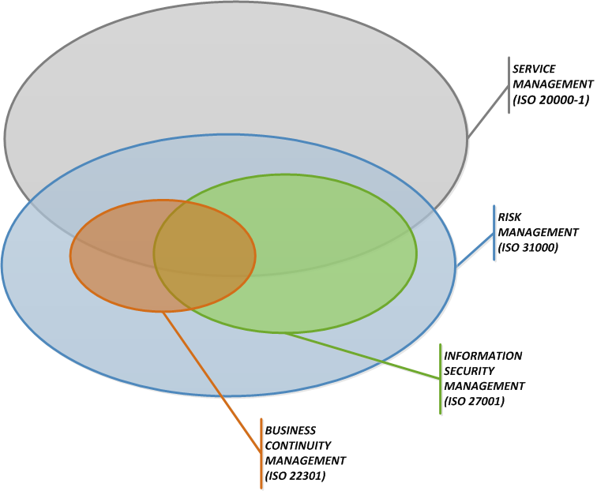
Within BravoSolution context and on basis of its specific business model, the above quoted interrelations among the management systems adopted by the Company are better described by the following picture.
Figure K2 — Interrelation among Management Systems that constitute the Management Integrated System adopted, on basis of BravoSolution organizational context and business model.

Traffic screening, intrusion monitoring, detection and prevention
The system is protected against virus, spam, malicious software and dangerous active content at gateway level through the several integrated features offered by border firewall technology. With this configuration, all flows of e-mails, attachments, uploads, downloads etc. are scanned at Internet firewall level. The “virus definitions” and threats databases are constantly updated by an automated process.
In addition to the security solution at gateway (firewall) level, the application solution uses a Linux command line antivirus that is called to scan newly uploaded files (attachments) under application control. This is an active process initiated by the application, which will then present the user with an intelligible error code has the attachment been declared infected by the antivirus. The process is detailed in the following paragraphs.
BravoSolution, as an independent third party service provider exclusively, cannot possibly grant itself the right to modify the attachment files. In case of infected attachments, two options are available under ‘BravoSolution Platform’ instance parameterization:
- The supposedly infected attachments are refused and the user is invited to upload files scanned through up-to-date antivirus software.
- The supposedly infected attachments are accepted and the user is warned. The potentially infected attachments are therefore marked as infected.
BravoSolution adopts a modern active defense technology based on an IPS firewall module. The IPS functionality can monitor and block the following types of attacks:
- Denial of Service Attacks
- TCP/IP Attacks
- Web and Application Vulnerabilities
- Network Probing
- HTTP Worms

To achieve these top results the IPS uses a number of advanced security techniques, such as TCP Sequence Number regeneration, real-time analysis of network connections behavior and real-time update of black-lists.
BravoSolution’s IPS is also specifically configured to monitor the registration process for any suspicious activity (including ‘bot’ activities) through a combination of rules detecting speed of registration, multiple user transactions over unrealistically limited time period, repetitive registrations through same IP address, etc. Our solution is therefore able to detect and prevent ‘bot’ or ‘robot’ transactions (i.e. bots) from creating new accounts on the website to post or upload advertisements.
Security logging and notification
The heterogeneous information stored locally in log files by each software layer (including web servers, application servers, database servers) is collected and stored in a centralized repository based on Logstash and other open source technologies for indexing, alerting and reporting. Centralized logging allows for a single, time and format consistent repository for problem determination and user action analysis, with the added value of simplifying root cause identification since all logs from all the involved software layers can be analyzed together at the same time.
Security patch management
All software components in BravoSolution’s architecture are continuously monitored for patches and software updates, especially security subsystems. Patch notifications impacting any of the critical areas of the security architecture are immediately implemented, per the related ISO Procedure.
Examples can be found below.
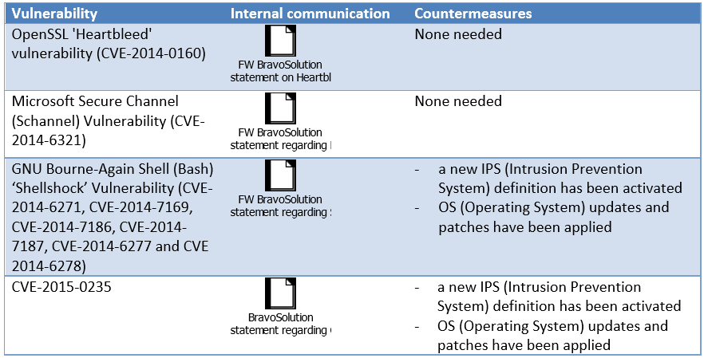
Third party vulnerability assessments and audits
The GoA audits in the BravoSolution business context can be classified in the following main categories:
- Document reviews
- Penetration tests
- Site visits
- Demo of specific platform configuration before go-live
- Disaster Recovery Tests
- Audits that require access to production environment data

A systematic external Penetration Test is regularly (12-18 times per year) carried out against BravoSolution’s applications exposed on the Internet. These tests are conducted through the Internet, typically from the facilities of the organizations responsible for the testing. The aims of the tests are:
- To find known vulnerabilities in the targeted IP address;
- To exploit, where possible, those vulnerabilities, in order to obtain unlawful access to resources;
- To review known vulnerabilities for the identified software and hardware.
Automated scans and manual penetration tests are carried out in the attempt to gain access to the system.
SchedulePro
EDP Software agrees to comply with the Government of Alberta Information and Security programming requirements. Successful compliance will require a partnership between EDP Software and the GoA responsible parties. EDP Software will work with the GoA Information Security Experts to ensure they have the necessary data required to review and maintain SchedulePro as their employee scheduling system. Any EDP Software employees involved in the project are available to go through GoA training on Information Security and Privacy as required.
Information Security Policies and procedures are handled in the following ways:
- Contract - Every employee and contractor at EDP Software has contractual obligations as part of employment to follow EDPs privacy, confidentiality processes and procedures.
- Company Policies and Handbook - The EDP Software employee handbook lays out company policies around privacy, security, and employee code of conduct which safeguard data and information
- Data isolation and security limitations - Customer data is isolated in regular production environments. Access to customer data is provided only on an as needed basis. This reduces the possibilities of any procedural breaches
- Policies and Procedures - Any interactions with customer data are governed by internal policies and procedures. Whenever possible, the procedures are automated by the system to ensure that human error can not occur.
- Training and continuous improvement:
Any employees who have access to customer data are trained on how to utilize our systems and how to follow procedures.
Additionally, employees who are part of the select group with those privileges are also part of our continuous improvement group. This means that the employees are part of a process to continually find and then improve our policies and procedures. This ensure buy in from all levels of the organization and solicits feedback from those who see any gaps or issues by being on the front lines.
Security threat and risk assessment practices
- Microsoft Best Practices – SchedulePro is built using the Microsoft platform of products. As part of our development process, EDP software follows the Microsoft Best Practices guidance on development and security. These development guidelines specify approaches for architecture, authentication, encryption and other security related practices. Microsoft also publishes application hosting best practice guides and EDP uses this guidance to deploy our production servers in a secure configuration.
- Security Development Lifecycle – EDP Software follow the Microsoft Security development lifecycle process which drives a holistic approach to security in applications. This includes design reviews, security threat modelling and risk assessment, and internal security reviews.
EDP Software uses many tools to test system security.
- FXCop
- Cat.Net
- Microsoft Visual Studio Code Analysis
- OWASP ZAP
- Microsoft Baseline Security Analyzer
- Microsoft Best Practices Analyzer
- Microsoft System Center Advisor
Many of these tools are interactive guides or have been integrated into our build processes and do not provide reports that we can easily share (They alert developers from within our development environment so issues are fixed before the code is ever submitted to source control).
GenTax
The GenTax solution will be hosted by Oracle and therefore the processes and controls described under the Oracle section above will apply.
  - describe, for any hosted services, under which circumstances the Pre-Qualified Proponent may consider multi-tenancy in the Cloud based and how the ERP Solution will be impacted by the consideration
Details for the sub-components that form part of our solution are below, where applicable.
Oracle
The only component of the Oracle SaaS offerings that may be considered “multi-tenant” in the traditional sense is Oracle Talent Acquisition Cloud Service (OTAC). This is a dedicated multi-tenant recruiting cloud service that resides in a technical environment (Infrastructure and Platform) that is physically separate from the rest of a customer’s integrated ERP/HCM/Cx isolated tenant environment. Customer data in OTAC is kept in a separate database schema from other tenants and access is controlled via Role Base Access Controls (RBAC). The architecture provides flexibility of deployment as OTAC can be integrated back into any ERP/HCM application including on premise. In the past, customers with pressing recruiting needs, have elected to make OTAC their first deployment.
BravoSolution
In the multi-tenant model, all customers share the same hardware resource pooling and benefits of the same product upgrades, security patches, service levels.
BravoAdvantage makes use of a sophisticated application mechanism aimed to guarantee the privacy of shared mode customers. Customers can be assured that their data are strictly separated from other customers’ data hosted on the same shared infrastructure. This security issue is addressed through the enforcement of database policies which provide strict row level security requirements for each table. In the BravoSolution Cloud the separation between customers’ instances is enforced by application-level controls running within a multi-tenant architecture. Regular third party & internal audits ensure best practice approaches to business continuity, data & network security, availability, continuous improvement and segregation of duties are maintained by BravoSolution year over year.
  - describe how data is secured between as between tenants
Details for the sub-components that form part of our solution are below, where applicable.
Oracle
Oracle Cloud applications leverage the next generation tenancy model which we refer to as ‘Advanced Virtualized Tenancy’. In this model each customer accesses their own private database instance, not a database shared with other cloud customers. Our customers still enjoy the advantages and benefits of the cloud in terms of broad network access, hardware resource pooling for unlimited performance and rapid elasticity for unexpected demand. Oracle engineered its Cloud on its own highly performance hardware and leading technology, offering the best possible performance and security controlled environment.
The benefits of this approach, apart from securing the customer’s data are:
- Simple, subscription-based pricing ensuring lower initial costs, deployment on preconfigured environments, and faster time to benefit
- Virtualized segregation of your data so that only you can access them
- The possibility to upgrade when convenient for the customer (for instance if you are on an intense recruitment campaign, you can request a delay of the upgrade)
- With virtualization, Oracle is able to scale the resources allocated to each customer individually. Oracle monitors the resources with Enterprise Manager and is thus able to adapt allocated resources. For instance, if you plan to bulk upload data, add more users, or manage more employees after a merge and acquisition.
The architecture is redundant and multi-tiered, with end-user traffic limited to the front Demilitarized Zone (DMZ) tier of Web servers only. Network traffic boundaries and system/application interfaces are restricted and only authorized connections are allowed. Using this approach to Cloud Computing and Multi-tenancy, Oracle maintains secure and unique database instances for each customer’s data within a database repository. Customer data sets are not comingled with other customer’s data.
Redundant, managed firewalls, using stateful packet inspection, provide barriers between tiers of the architecture. All traffic is filtered to allow only valid web connections into the network. Traffic within each tier is restricted and controlled via firewalls to control access between Oracle Cloud service tiers by allowing only authorized traffic. Firewalls are deployed in a layered approach to perform packet inspection with security policies configured to filter packets based on the protocol, port, source, and destination IP address to authorized sources, destinations, and traffic types.
Kyriba
Data exchange is covered by SOC 1 and SOC 2 audits.
BravoSolution
In the multi-tenant model, all customers share the same hardware resource pooling and benefits of the same product upgrades, security patches, service levels.
BravoAdvantage makes use of a sophisticated application mechanism aimed to guarantee the privacy of shared mode customers. Customers can be assured that their data are strictly separated from other customers’ data hosted on the same shared infrastructure. This security issue is addressed through the enforcement of database policies which provide strict row level security requirements for each table. In the BravoSolution Cloud the separation between customers’ instances is enforced by application-level controls running within a multi-tenant architecture. Regular third party & internal audits ensure best practice approaches to business continuity, data & network security, availability, continuous improvement and segregation of duties are maintained by BravoSolution year over year.
  - describe how, for any hosted services, the GoA can have assurances that their data is secure at all times and conform to the GoA security and Cloud standards listed in section 3.1.8
Details for the sub-components that form part of our solution are below.
Oracle
Oracle Cloud Services operate under Policies which are aligned with the ISO/IEC 27002 Code of Practice for information security controls, from which a comprehensive set of controls are selected, as described by ISO/IEC 27001.
The internal controls of Oracle Cloud Services are subject to periodic testing by independent third party audit organizations. Such audits may be based on the Statement on Standards for Attestation Engagements (SSAE) No. 16, Reporting on Controls at a Service Organization (“SSAE 16”), the International Standard on Assurance Engagements (ISAE) No. 3402, Assurance Reports on Controls at a Service Organization (“ISAE 3402”), or such other third party auditing standard or procedure applicable to the specific Oracle Cloud Service. Audit reports of Oracle Cloud Services are periodically published by Oracle’s third party auditors, although reports may not be available for all services or at all times. Customer may request to receive a copy of the current published audit report available for a particular Oracle Cloud Service.
Kyriba
When we set out to develop the world’s first true SaaS requirement for Treasury Management Services, connecting the world’s largest customers to their banks, the absolute requirement to deliver bank-grade security was, and continues to be, foremost in our minds. Our priority is to operate a superior cloud infrastructure that delivers the best treasury management solution. We are aware that security is essential to be successful, and we also recognize the need to be attentive to security levels utilized by our clients. Securing all components of our solution – from physical machines to data and file transmissions – is an ongoing effort and a goal that is core to our organization and operations. Our business model and data content require that we pay the utmost attention to security, and the system has been designed to apply high-level security models, from coding to implementation, which is regularly audited.

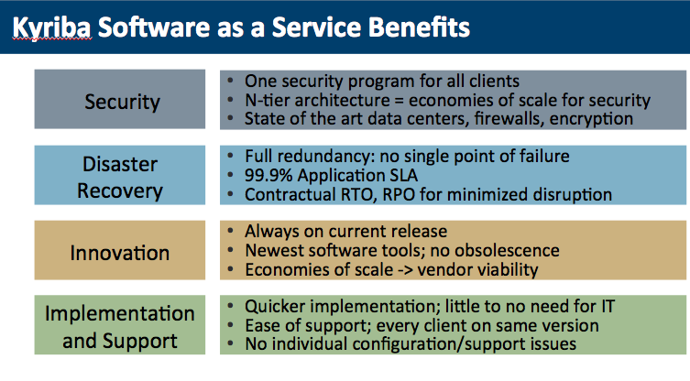
We commit to ongoing SOC 1 and SOC 2 audits contractually. The principles that we are audited against reflect the GoA security and cloud standards.
BravoSolution
BravoSolution perceives the current Canadian data privacy directive (DPA/PIPEDA) concerning the processing of personal data through the adoption of the ISO/IEC 27018:2014 standard (Information Security Management System for Personally Identifiable Information in public clouds) concerning management of PII data acting as PII processors. BravoSolution guarantees through the term of the contract to comply with the strictest existing and future data protection directives and laws of the Canadian Government.
All log and audit data is held in a secure datacenter and is encrypted when backed up and backups never leave the datacenter. Under the terms of the DPA, we regard the GoA as the Data Controller – and BravoSolution as the Data Processors. The data we hold belongs to the GoA and is not routinely accessed by us other than upon request from the GoA. If data has to be physically extracted and transmitted to the GoA, secure means of transport and delivery will be agreed.

SchedulePro
EDP Software agrees to comply with the Government of Alberta Information and Security programming requirements. Successful compliance will require a partnership between EDP Software and the GoA responsible parties. EDP Software will work with the GoA Information Security Experts to ensure they have the necessary data required to review and maintain SchedulePro as their employee scheduling system. Any EDP Software employees involved in the project are available to go through GoA training on Information Security and Privacy as required.
GenTax
The GenTax solution will be hosted by Oracle and therefore the processes and controls described under the Oracle section above will apply.
GenTax was developed using built-in security, secure-by-design, and best-of-breed defensive programming practices. In addition to the security that is integrated into the FAST development process, FAST contracts with independent third-party security firms to perform penetration testing and analysis of the application’s overall security. Such testing is conducted at least once per major version release (some FAST clients also choose to conduct their own independent evaluation of the application). The security assessment involves a comprehensive security evaluation and penetration testing, including automated testing, manual testing, configuration review, and privilege escalation. Penetration test scenarios are designed to simulate both internal and external attacks. Security-review testing includes testing for Open Web Application Security Project (OWASP) Top 10 vulnerabilities, CWE/SANS Top 25 programming errors, Web 2.0 vulnerabilities, and critical database vulnerabilities. In the most recent test, the GenTax software architecture received a positive rating on its overall security-risk posture. Combined with a secure computing environment, the overall system has been found to be resilient to known attack patterns and attacks launched using known automated attack toolkits.
  - describe, for any hosted services how infrastructure and Software updates, upgrades etc. are confirmed and pre-approved with the GoA to uphold the necessary standards and governance
Details for the sub-components that form part of our solution are below.
Oracle
Oracle Cloud Operations performs changes to cloud hardware infrastructure, operating software, product software, and supporting application software that is provided by Oracle as part of the Services, to maintain operational stability, availability, security, performance, and currency of the Oracle Cloud. Oracle follows formal change management procedures to review, test, and approve changes prior to application in the production service.
During the Cloud Services term, Oracle tracks the release levels of various components within the customer's Services environment (for example, hardware, associated device drivers, operating system, and Oracle virtualization software). Oracle will periodically deploy Oracle patches, maintenance releases, and updates to the customer's Services environment to keep the Oracle Programs provided by Oracle as part of the Cloud Services at a current release version or to enhance service performance. Software upgrade to the customer's Services environment is governed by Oracle's change control procedures, as described in the Oracle Cloud Hosting and Delivery Policies.
Patches are typically applied on a quarterly basis. Oracle requires all Cloud Services customers to keep the software versions of the Services current with the software versions that Oracle designates as generally available (GA) for such Services. Software updates or upgrades will follow the release of every GA release and are required for the Services in order to maintain version currency. “Minor (point upgrades) releases” are incorporated into the quarterly maintenance cycle.
During an upgrade cycle, customers are notified that a new release is available. Customers can then select an upgrade slot that works in support of their business needs. Oracle offers a sizable 2 to 3 month window within which customers can select their upgrade slot. Customers can then remain on their current release (N-1) until their selected upgrade time; while at the same time, other customers are up-taking the latest release (N).
Changes made through change management procedures include system and service maintenance activities, upgrades and updates, and customer specific changes. Oracle Cloud change management procedures are designed to minimize service interruption during the implementation of changes. Oracle has a process in place for roll-back in the event that the upgrade is not successful both at the Oracle Cloud software level as well as at the infrastructure level. In the event this happens, Oracle Production staff will escalate the issue through the management team. The management team will prioritize the event based on severity.
Oracle Cloud conducts development and testing activities on environments outside of, and physically separated from, the production and nonproduction environments that are provided by Oracle Cloud as part of the service. Your Content is not used within these development and testing environments as per Oracle’s internal security policies, except that Oracle may periodically refresh the corresponding non-production infrastructure from the production environment, to support upgrade, patching, and release testing.
For security patch bundles that Oracle deploys for designated Oracle Cloud Services, Oracle will apply the security patch bundle to the production environment of the Cloud Service after Oracle successfully completes testing on the non-production environment where available.
Oracle reserves specific maintenance periods for changes that may require the Services to be unavailable during the maintenance period. Oracle works to ensure that change management procedures are conducted during scheduled maintenance windows, while taking into consideration low traffic periods and geographical requirements. The maintenance windows provide a cadence wherein patches are applied to non-production at the beginning of the month and to the production environment at the end of the month.
Oracle may be required to execute emergency maintenance in order to protect the security, performance, availability or stability of the Services. Emergency maintenance may include program patching and/or core system maintenance as required. Oracle works to minimize the use of emergency maintenance, and to the extent reasonable under the circumstances as determined by Oracle, will work to provide 24 hours prior notice for any emergency maintenance requiring a service interruption.
Kyriba
Our application is developed in line with the Scrum form of Agile Development with architecture designed to safeguard against fundamental application vulnerabilities and infiltration. The program provides for systematic monitoring and evaluation to ensure that standards of quality are being met, have been and continue to be engaged on our TMS. Quality evaluation and acceptance criteria for information systems and infrastructure, software enhancements and upgrades, and newly engineered versions are established, documented, and tested in the system(s) as a matter of process and development controls. These are carried out both during engineering development and prior to production acceptance implementation in order to maintain the highest standards of security.
BravoSolution
The goal of release and deployment management procedure
Release and deployment management procedure aims to build, test and deliver the BravoSolution platform that provides services to the GoA. The goal of release and deployment management procedure is to deploy releases into in an effective and secure way to efficiently deliver, support and maintain the service to the GoA, according to required warranties and service levels. Release and deployment management also take in consideration that suitable training will take place to ensure ongoing support of the new service.
The purpose of release and deployment management is to:
- Define and agree release and deployment plans internally with R&D and QA Team and finally with the GoA
- Ensure that each release package consists of a set of related assets and service components that are compatible with each other
- Ensure that integrity of a release package and its constituent components is maintained throughout the transition activities and that don't compromise the recorded configuration of deployment
- Ensure that all release and deployment packages can be installed, tested, verified, to reduce the risks related to the new or changed service, and take necessary corrective action
The scope of release and deployment management
The scope of release and deployment management includes the processes, systems and functions to package, build, test and deploy a release into operation. The release process commences with receipt approved request changes to build a production ready release package. It acts delivering change, faster and at optimum cost and minimized risk. Give value assuring that the GoA and its users can use the new or changed service in the way that demonstrates the value outcome has been achieved. The release will typically consist of problem fixes and enhancements to the service.
Releases are divided into:
- Major software releases and eventually hardware upgrades, normally containing large areas of new functionality. A major upgrade or release supersedes all preceding minor upgrades, releases and emergency fixes.
- Minor software releases, normally containing small enhancements and fixes. A minor upgrade or release supersedes all preceding emergency fixes.
- Bug or emergency software fixes, normally containing the corrections to a small number of known problems.
SchedulePro
SchedulePro is offered as a cloud service, fully hosted and supported in Canada. All configuration and management of the service is handled by EDP Software. As part of the ongoing service fee, new versions of the software will become available to all users when they are ready. In the SaaS delivered system, upgrades are managed by EDP.
EDP guarantees that any software enhancement created for GoA will be available in subsequent releases. EDP provides early access test environments to customers so they can ensure that any new versions of the product continue to function.
Security Development Lifecycle – EDP Software follow the Microsoft Security development lifecycle process which drives a holistic approach to security in applications. This includes design reviews, security threat modelling and risk assessment, and internal security reviews.
EDP Software uses many tools to test system security:
- FXCop
- Cat.Net
- Microsoft Visual Studio Code Analysis
- OWASP ZAP
- Microsoft Baseline Security Analyzer
- Microsoft Best Practices Analyzer
- Microsoft System Center Advisor
Many of these tools are interactive guides or have been integrated into our build processes and do not provide reports that we can easily share (They alert developers from within our development environment so issues are fixed before the code is ever submitted to source control).
GenTax
The GenTax solution will be hosted by Oracle and therefore the processes and controls described under the Oracle section above will apply for Infrastructure changes.
Software updates available from the FAST Development Center can appear in one of the following three forms.
- Hot Fixes – FAST may recommend applying critical changes to a core component as soon as possible. Critical changes are those required for a client to continue doing business in a reasonable fashion. Hot fixes contain documentation, components, and scripts for any associated database changes. FAST releases hot fixes on an as‐needed basis.
- Service Packs – FAST makes changes to core components periodically (typically on a quarterly basis). These changes take the form of service packs. Service packs contain documentation, components, and scripts for any associated database changes. Agencies can decide to implement some, all, or none of the non-critical updates in a particular service pack based on their business needs and priorities.
- New Software Versions – New versions (upgrades) of the core software are released periodically. A new version typically includes both functional enhancements and changes that leverage the evolution of the implementation platform technology—for example, new versions of operating systems and database management systems. Upgrades are typically released every few years. We do not require clients to upgrade to new versions of our software. FAST continues to support all clients and client software versions for agencies that subscribe to annual maintenance. We do suggest that clients avoid falling behind by more than two releases of the software since most enhancements within service packs pertain to the latest versions of the application
  - based on, an understanding that Province has adopted a Single Sign On (SSO) approach utilising an active directory, describe how the Province’s employees will be able to access the ERP Solution using GoA id (and SSO)
Details for the sub-components that form part of our solution are below.
Oracle
Oracle supports an open standards-based Identity Management solution that enables Oracle Cloud customers to use their existing enterprise identities and credentials (stored in LDAP repositories) to gain SSO access to Oracle Cloud Services.
Oracle Cloud Applications can integrate with on premise identity management platforms via SAML 2.0. Oracle supports Microsoft Active Directory Federation Servers (ADFS) 2.0 for authentication, as well as others listed below. An interface may be created to synchronize with Active Directory (AD) using the delivered integration tools and delivered REST services. REST APIs in Oracle Cloud Applications use the SAML 2.0 global server-side security policy.
Oracle Cloud Applications currently supports Federated SSO, an access method that supports Federated Identity using technology standards, such as Security Assertion Markup Language (SAML) 2.0. The Oracle Cloud Service acts as the Service Provider (SP). Customers must set up one of twenty-seven (27) pre-approved federation servers as Identity Provider (IdP). The pre-approved servers include:
- AuthAnvil
- Big IP F5 APM
- CA Single Sign-on formerly CA SiteMinder))
- Centrify
- Entrust GetAccess
- ForgeRock OpenAM
- Google IDP
- IBM Security Access Manager
- IBM Tivoli Access Manager
- Microsoft ADFS 2.0+
- Microsoft Azure Active Directory (Azure AD)
- NetIQ Access Manager
- Okta (SAML 2.0 compliant versions only)
- OneLogin
- Open SAML
- Oracle Access Management (OAM) 11gR2 PS3+
- Oracle Identity Cloud Service (IDCS)
- Oracle Identity Federation (OIF) 11g+
- Ping Federate 6.0+
- Ping One
- SailPoint Identity
- SecureAuth
- Shibboleth 2.4.0+
- SimpleSAMLphp
- SSO EasyConnect
- SURFconext
- WSO2 Identity Server
Other federation servers are supported for an additional fee. For the purposes of the GoA implementation and the Province’s need to support multiple IdPs, we are proposing to leverage Oracle Identity Cloud Service (IDCS) as the authentication hub through which all cloud access will be gated. IDCS is a Platform as a Service offering and described further below.
Components of our solution will be provided by Oracle Platform As a Service (PaaS)/ Infrastructure As a Service (IaaS). A description of the SSO capabilities within Oracle Paas/Iaas is below.
Oracle PaaS/IaaS
The key component that underpins all modern and future Oracle Cloud services is Identity Cloud Service (IDCS.) IDCS is Oracle’s next generation comprehensive security and identity platform that is cloud-native and designed to be an integral part of the enterprise security fabric, providing modern identity for modern applications, such as the proposed ERP solution. It provides a powerful set of hybrid identity features to maintain a single identity for each user across their on premise and in the cloud services while delivering a seamless user experience.
IDCS provides several options that can be utilized to satisfy this requirement:
- Federated identity into IDCS. One of IDCS’ core functions is to accommodate SAML, OpenID, and OpenID Connect assertions from trusted partners. Upon successful validations of such incoming objects, IDCS can provide SSO to any Oracle Public Cloud services including the proposed ERP solution
- IDCS also offers direct AD->IDCS reconciliation features where users are able to login to IDCS following a one time (and subsequent periodic updates) or credentials out of the trusted AD and into IDCS. Once this operation is complete, users are provided similar SSO capabilities into OPC as described in the previous bullet above
- Although not in scope for this RFP, a third option is available, where the Oracle IDAM stack can provide provisioning and access controls services from the on premise components of the Province’s existing solution to IDCS, once again supporting SSO to Oracle Public Cloud services.
Kyriba
SSO is supported using the SAML 2.0 protocol with a HTTP POST binding. Both variant “Service Provider initiated SSO” and variant “Identity Provider initiated SSO” are supported.

BravoSolution
Figure K3 — Example SSO diagram
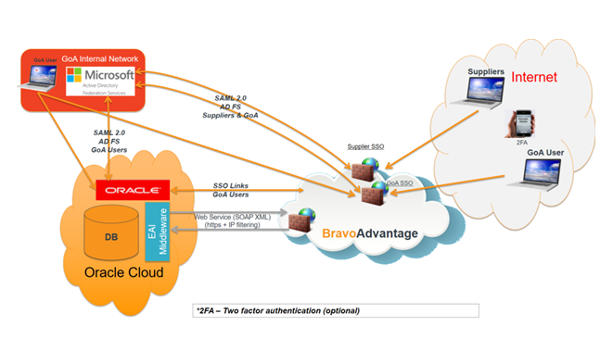
The BravoAdvantage platform can be configured to be fully capable of delegating the authentication process to a trusted external system (idP). The solution is compliant with any SAML 2.0 identity provider, OpenId, MS AD LDAP, Digital Certificates (PKI) & Server to Server Trusted SSO. The user registration/deregistration process can be supported via web services (BravoAdvantage Integration Module). This SSO service is an additional component of the BravoSolution SaaS solution and is ISO27001 certified.
SchedulePro
In addition to system generated sign-in credentials, SchedulePro also supports some Single Sign On (SSO) protocols. SSO allows for sign-in to be managed by customer authentication systems.
GenTax
GenTax supports LDAP-based user authentication and internal user authentication. All network-transmitted data sent to, from, and through GenTax is protected through use of the following best-practice security designs and safeguards.
- GenTax uses industry-standard message specifications and formats for communications with external applications. Business services use standard parameters encoded in binary format.
- Windows Communication Foundation (WCF) message-level encryption algorithms can be enabled in accordance with agency security policies.
- GenTax encrypts the data in transit within an agency’s network. Standard SSL/TLS encryption in the browser is used for messaging between client workstations and web servers.
- Message data is signed and encrypted using SSL/TLS for external communication or for internal WCF messages.
- Inbound messages are validated for allowable data to prevent compromising content. Message attachments are scanned at the server using standard server-based virus scanning software.
- Communication between the application and database servers is encrypted using SSL/TLS certificates.
- Data at rest within Microsoft SQL Server is encrypted using Transparent Database Encryption (TDE). TDE performs real-time I/O encryption and decryption of data and log files. Data at rest is encrypted by using AES and 3DES encryption algorithms. Encryption of the database file is performed at the page level. The pages in an encrypted database are encrypted before they are written to disk and decrypted when read into memory. TDE does not increase the size of the encrypted database.
- Multi-channel authentication, when enabled for agency or e-Services users, requires users to enter their username, password, and a security code sent to them by e-mail or text message. Multi-factor authentication, when enabled, replaces the security code used for the multi-channel approach with a Time-based One Time Password (TOTP) generated by either hardware tokens or software tokens (such as Google authenticator or Microsoft authenticator). This approach ensures that a password alone is not enough to access the system. A user must “know something” and “have something” to log on.
- Agencies can enable field-level security by choosing configuration options that define when users can view or update specific fields on screens. This feature can be used to hide or disable editing of sensitive information (such as bank account details) from users who need access to a particular screen but have no business need to see or edit all of the available information.
- GenTax user sessions may be locked manually by users or automatically by the system after a defined period of inactivity. Once a user session is locked, no system information can be viewed and the user’s credentials must be provided again to resume the session.
  - describe how externals users will be able to access the ERP Solution and related components through the federated identity management model
Details for the sub-components that form part of our solution are below.
Oracle
Invited external users would connect via SSO Connection, connecting using the Province’s Identity Providers (IdP) via Identity Cloud Service (IDCS) and SAML 2.0. This implies that users such as Suppliers or Grant Applicants would need to register prior to connecting. This allows the vetting of credentials as well as the application of Role-Based Access Control authorizations to limit data, menu and function access. The same controls are in place as described in the response to f) above.
For some modules like Recruiting or Social Sourcing, authentication may not be required until the external user creates an account in the Recruiting Career Section to apply for a position. The following are the different modes that can be configured for applicant access:
- Invited User (Guest) Access - The majority of Social Sourcing capabilities are open to the public. People can freely visit the site to search for and post jobs. This is the access mode for external candidates when the application is configured only in "work site" mode or "work site and referral" mode.
- Promising user access - a user can be partially connected (Amazon Style). The user’s screens show that they are logged in as user X, but when they try to perform actions other than a browsing task, they are prompted to sign-in. A user likely comes to the site by clicking on an email link sent to his/her email account. The user and his/her e-mail are typically from the user registration workflow.
- Social Network Connection - Connection with accreditation from Google, Yahoo, Facebook, LinkedIn, Twitter.
- Login by Localized Username / Password - Credentials are stored locally in the cloud DB. User needs to be logged in to either refer someone or access the recruiter feature.
The Province effectively has full flexibility over which modes it wishes to offer external users.
Components of our solution will be provided by Oracle Platform As a Service (PaaS)/ Infrastructure As a Service (IaaS). A description of the federated identity management capabilities within Oracle Paas/Iaas is below.
PaaS/IaaS
The key component that underpins all modern and future Oracle Cloud services is Identity Cloud Service (IDCS.) IDCS is Oracle’s next generation comprehensive security and identity platform that is cloud-native and designed to be an integral part of the enterprise security fabric, providing modern identity for modern applications, such as the proposed ERP solution. It provides a powerful set of hybrid identity features to maintain a single identity for each user across their on premise and in the cloud services while delivering a seamless user experience.
One of IDCS’ core functions is to accommodate SAML, OpenID, OpenID Connect assertions from trusted partners. Upon successful validations of such incoming objects, IDCS can provide SSO to any OPC services including the proposed ERP solution
Kyriba
When a user signs in selecting the single sign on option, internally, a redirection to the Identity provider is performed. Our solution then receives all the information from the Identity provider that is required to identify the user and to create a session. The access to our portal is then transparent for the user.
BravoSolution
External users can register on the BravoAdvantage platform, then be authorized through a workflow and assessment process, prior to gaining access to the platform. As soon as a new supplier is registered and approved on the BravoAdvantage Platform, the supplier/user master data is synchronized into the database of the GoA authentication service for digital certificates (the BravoAdvantage user id information should be saved into a specific field of the GoA database). Client-side certificates can be distributed by the GoA identity provider to further enhance the security of supplier access and control to the platform. The digital certificate must be adherent to rfc5280 ‘Internet X.509 Public Key Infrastructure Certificate and Certificate Revocation List (CRL) Profile’. The BravoAdvantage requires the presence inside the certificate of the ‘Extended Key Usage’ extension which would contain the ‘id-kp-clientAuth’ usage purposes.
SchedulePro
In addition to system generated sign-in credentials, SchedulePro also supports some Single Sign On (SSO) protocols. SSO allows for sign-in to be managed by customer authentication systems.
GenTax
GenTax supports LDAP-based user authentication and internal user authentication. All network-transmitted data sent to, from, and through GenTax is protected through use of the best-practice security designs and safeguards described in the section above.
  - for the proposed ERP Solution include provisions and detail capabilities and recommendations for upholding secure role based access to all Users
User access to data is a key area of risk within Cloud implementations. With every change and upgrade, organizations are required to ask questions about data access (who can see this data), data visibility (is this data shared between different business groups), and data privacy (is this data public, internal or confidential). Organizations would need to understand the many layers of data risk that include application data risks, regulatory risks, third party risks (vendor data storage and their security concerns), business continuity risks etc.
We understand that data security within your organization can be complex to implement and maintain. Deloitte has extensive experience with public sector organizations, assisting with designing, building and implementing data security using a risk based approach. While Oracle Cloud provides several layers of data security (Business Unit, Segment, Payment, etc.), we will work with you to determine the best strategy to balance the risk of sensitive access against the maintenance complexity with multiple data security elements.
Our security and controls framework will help you answer the following key questions your auditors/ regulators and other stakeholders may have, with respect to the implementation:
- How will you satisfy both the business objectives and the regulatory / compliance requirements, such as:
Your ten key security directives
External financial reporting expectations
Privacy of customer / employee data (FIPPA, HIPAA, etc.)
Reduce the risk of intentional fraud or unintentional error to the organization
- How will you know if you have appropriate segregation of duties in the business processes or within IT?
- Do you have adequate policies and procedures for effectively changing or removing access when users change jobs or leave the company?
- Our approach to cyber security follows a risk-based approach. Risks that are relevant to your organization will be identified and appropriate controls will be recommended to mitigate those risks in a cost-effective manner.
As an integral part of any cloud implementation the below must be considered:
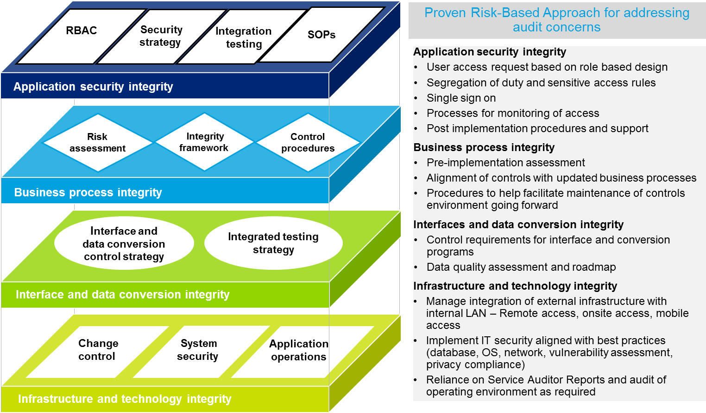
Our approach to security design and build is iterative with various checkpoints to ensure thorough testing and adequate involvement from the required stakeholders. Timely signoffs of security and controls deliverables are also built into the project timelines. This enables the stakeholders to remain connected with the security and controls work stream and provide the required input as necessary.
The table below outlines the objectives, key activities and key deliverables by project phase for security.
Phase | Deliverable | Description and value to client
Plan | Security and Controls Project Plan | Inclusion of security and controls activities within the overall project plan.  This will help the client understand when security and controls work will be performed and when related deliverables can be provided to their internal/ external auditors.
Architect | Application Security Strategy | The Application Security Strategy contains a set of security considerations, recommendations, and strategies for managing the company's application security risks across business processes, including those hosted in the Cloud. This document defines the plan to address application security risks throughout the project.
Architect | Security Base Role Design | The Security Base Role Design identifies security roles that are aligned to the to-be process flows and contain the appropriate functional tasks for each role based on the business requirements identified in the design workshops. This deliverable should include a listing of security roles that depict the associated functional tasks designed with segregation of duty concepts, required data restrictions, and additional security restrictions driven by the business requirements for each role. This deliverable is used by security specialists to configure security roles in the development environment.
Architect | Segregation of Duties and Sensitive Access Matrix | The Segregation of Duties and Sensitive Access Matrix is created to track the agreed upon rules that will be applied to the system environment. Segregation of Duties (SOD) and sensitive access controls are documented for to-be sub-processes. The matrix defines system access rules that allow for the separation of incompatible duties that could allow a user to commit and conceal fraud, which may result in financial loss or misstatement to the company. Each of these components are documented, tracked, and approved.
Configure & Prototype | Security Roles | The Security Roles are the configured base security roles that are created by building the appropriate security objects for application security roles as defined in the Security Base Role Design. This includes configuring the required actions as well as organizational hierarchy and functional data restrictions within the roles. The final product is reviewed, accepted, and uploaded as part of production go-live.
Configure & Prototype | Security Access Procedures | The Security Access Procedures deliverable defines the approach for the provisioning of user access to the technology solution. It describes the processes in which access is managed and provisioned and serves as a guide to handle end user access requests and authorization issues. It is used by security administrators to implement and enforce user access provisioning policies.
Configure & Prototype | Security Testing approach, scenarios and scripts | The Role-Based Security Test Approach documents the approach for testing the production application security for defined business roles. It includes test types and approaches, test tools strategy, test roadmap, testing roles and responsibilities, testing environments, defect tracking, and test tasks.  Role-Based Security Test Cases provide a detailed outline for the teams to perform unit testing on the proposed security roles gathered during design. This document includes the test ID, description, role name, and applicable transaction codes/function names associated with the restricted role to guide the business process tester throughout unit testing.  The Role-Based Security Test Plan documents the work plan for unit testing production application security. It includes details of roles, resources, timelines, and scheduling/sequencing of test cases.
Test | Role Based Security Test Results | The Role-Based Security Test Results document details outcomes of the application security role testing, such as expected results, actual results, pass/fail determination, and tester and date test executed.
Test | Role-Level SOD Test Results | The Role-Level SOD Test Results document elaborates the SOD conflicts within Roles based on the business rules documented in the Segregation of Duties and Sensitive Access Matrix. These conflicts would either need to be remediated by modifying the Role definitions, or if the risk is accepted by management, compensating controls will need to be documented.
Deploy | User-Level SOD Test Results | The User-Level SOD Test Results document elaborates the SOD conflicts a user has based on multiple Roles that have been assigned to him/ her. These conflicts would either need to be remediated by taking away the Role assignments, or if the risk is accepted by management, compensating controls will need to be documented.
Details for the sub-components that form part of our solution are below.
Oracle
Oracle Cloud leverages the security principle of least privilege using the industry best practice of Role Based Access Control (RBAC). Using RBAC, application administrators control access to application functions and data (create, read, update, delete), ensuring that a given user only sees systems functions and rows of data pertinent to his/her job. Administrators configure job roles which map to job functions (duties) and data privileges. Application users are then mapped to the appropriate job roles for their respective positions, thereby enabling the user to execute the necessary tasks for their position. Using RBAC greatly simplifies the process of adding users or changing a user’s department or organization. It also increases security by ensuring that one central location and method is used to quickly and easily grant/revoke access to applications.
Figure K4 —RBAC Example
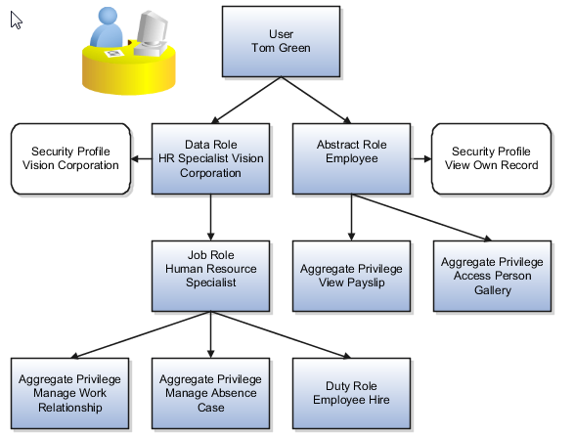
Many job and abstract roles are predefined in Oracle Applications Cloud’s security reference models. The reference models can accelerate implementation as customers need only define the data access policies and provisioning rules for users to gain secured access.
The Oracle Applications Security Console is an easy-to-use administrative interface that you use for most role-management tasks. For example, use the Security Console to:
- Review predefined job, abstract, and duty roles
- Create and manage custom job, abstract, and duty roles
- Typically, you copy a predefined role and use it as the basis for a custom role.
- Review the roles assigned to users.
- Compare roles.
- Simulate the Navigator for a user or role.
Figure K5 — Security Console (Visualization)
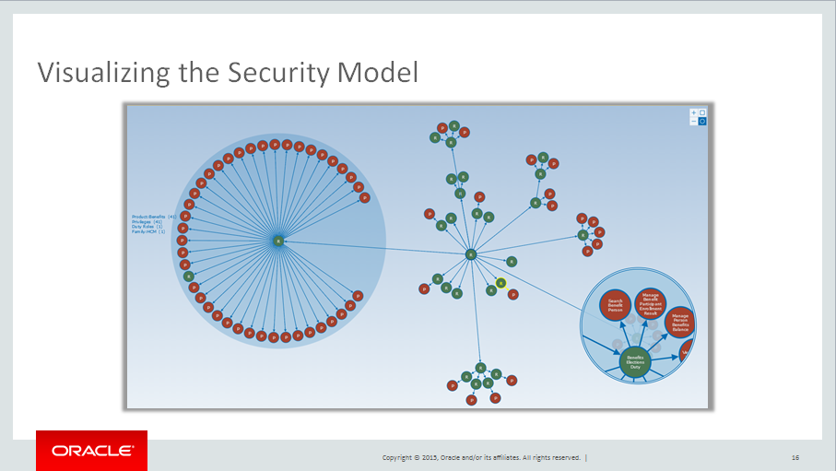
Components of our solution will be provided by Oracle Platform As a Service (PaaS)/ Infrastructure As a Service (IaaS). A description of the role based access capabilities within Oracle Paas/Iaas is below.
Oracle PaaS/IaaS
Currently, authorization remains the purview of individual applications with best practice suggesting that business owners are best positioned to define and grant permissions. IDCS support for Role-Based-Access (RBAC) is currently a roadmap item
Kyriba
Each user is assigned a unique User ID and granted an access profile as a member of a group(s). Users can be associated with one or more companies to filter the data that is available to them.
The assigned access profile determines the precise depth of system functionality that is available to the user. There are more than 100 separate functional areas that can be assigned and tailored to suit the role and responsibility of the group member or individual concerned. Clients can configure a sophisticated workflow with unlimited number of entry and approval steps along with the ability to personalize certain entry screens to restrict the entry/display to the only data that are relevant for a user to submit/complete/approve a data creation/modification.
BravoSolution
The system is designed to manage two distinct communities of Users, namely Buyers and Suppliers. The system associates users only to one of these two User groups, each with a specific scope of operations. Buyers for example are provided with Tender configuration and evaluation features, while suppliers have access to Tender response functionalities. Similarly, all features in the application are designed to ensure appropriate access to data and functionalities distinctly for buyers and suppliers.
User Profiles may be created to facilitate the assignment of access rights to users. Each User Profile carries a pre-defined set of access rights to those users being associated with it. User Profiles can also be quick and effective means of applying changes to access rights of a large community of users. Each change triggers an immediate update of access rights of all associated Users.
SchedulePro
Access and Permission Controls
SchedulePro includes pre-defined system roles, and also allows the creation of custom roles as a premium feature. Access the application is granted to users in three different categories:
- EDP administrators
- Customer back office users
- Customer employees
EDP administrators are authorized users within EDP who are assigned permission to access customer SchedulePro instances for the purpose of:
- Configuration and implementation
- Technical support
- System diagnosis
Only authorized EDP staff have access to this role.
Customer Back Office Users are customer users with special read or read/write access to the different module functionality within SchedulePro. Customer users are created and assigned by the customer’s main assigned system administrator.
The customer system administrator is assigned by the EDP implementation consultant. The customer administrator is sent a sign-in from within SchedulePro system to the customer administrator’s company email address. The sign-in password should never be communicated directly via email, or verbally.
In addition to system generated sign-in credentials, SchedulePro also supports some Single Sign On (SSO) protocols. SSO allows for sign-in to be managed by customer authentication systems.
Customer employees have no permissions to the configuration of SchedulePro. They are limited to seeing a restricted view of the schedule. Optionally employees can be configured to view their immediate co-worker group’s schedules, or broader views of the schedule. Employees are able to perform simple requests online including leave requests, trade requests, shift volunteering, and shift sign-up. Their specific permissions are defined on a per-employee basis.
Employee sign-in access is issued by back office users through the SchedulePro system. Employee sign-in passwords should never be communicated directly via email, or verbally.

Production data access
Only specific authorized senior EDP technical staff have access to the production environment and database. Access to production Specific data is only used for diagnosis and troubleshooting of system issues. Personal identifiable information is hashed and anonymized prior to creating and downloaded backups into test-diagnostic environments.
GenTax
Access to functionality such as administrative tools, applications, menus, records, fields, and reporting in GenTax is controlled by assigning a security identifier to each secured object. Each function within the system can have an associated security identifier. The system manages which functions are associated with the various security identifiers and the creation and maintenance of security identifiers.
GenTax provides role-based security access and grants user access to functionality using security groups. A security group is a collection of one or more security identifiers. Users are assigned to groups that grant them access to security identifiers for functions associated with the group. Security groups provide a flexible means of managing access to all levels of the system. Groups can be organized, for example, by roles, functionality, or individuals. A default group feature can automatically grant new users limited access to default function areas. User roles may in some cases be so specific that assignment to a group may not adequately define their access requirements. To support this situation, users can be directly granted individual access to secured objects and functions.
Partner-entity permissions can be granted through the same GenTax role-based security model that is used for establishing security/access profiles for internal agency users. Like other GenTax users, partner entities and, optionally, individuals within these organizations, are granted security privileges that grant their access to only the GenTax screens, data, and functions associated with their assigned role or responsibilities.
User activities in the system are logged to form a permanent record of user access. GenTax can track all actions performed by a user, including inquiry access to an account. The tracking tool can provide information about a user, such as the date and time an account was accessed, how many times an account was accessed, and whether a user was denied access. A higher-level overview identifies how frequently a user has performed various functions over time.
  - describe how data security and privacy will be managed for reporting in the ERP and also for the integrated BI components
Details for the sub-components that form part of our solution are below.
Oracle
Oracle Cloud provides the functionality to secure reports at the Role level. The application delivers a “Reports and Analytics” section from which two types of reports can be handled:
- BI Report (Business Intelligence Report) – Referred as “Reports” in BI Catalog
- OTBI Report (Oracle Transactional Business Intelligence Report) – Referred to as “Analysis” in BI Catalog
The “BI Catalog” section under “Reports and Analytics” allows us to perform the following tasks:
- Add/remove the roles who have the permission to access the report; and
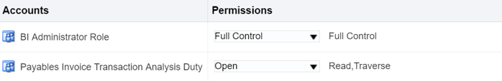
- Add/remove the different kind of access permissions that each role will have such as read, traverse, write, delete etc.
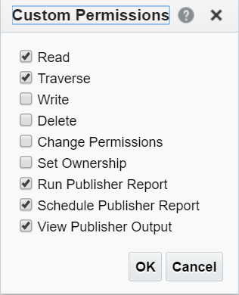
Without access to each and every folder in its navigation path, the role will not be able to access the report.
We will implement similar controls that is applied for the application for data security and privacy controls to balance the risk of sensitive access against the maintenance complexity with multiple data security elements.
Please refer to Appendix F for security and controls on reporting.
Kyriba
Each user is assigned a unique User ID and granted an access profile as a member of a group(s). Users can be associated with one or more companies to filter the data that is available to them. User access to reports is based on their groups.
BravoSolution
Based on the role and detailed access permissions of the users can limit their visibility to certain functions within the application and this can include their visibility into data and information across business units and other dimensional information within the system that can be related to the particular role or group that user may be a member of. Please refer to Segregation of Duty and Access Authorization for more information.
SchedulePro
SchedulePro includes pre-defined system roles, and also allows the creation of custom roles as a premium feature. User access to reports will be based on access to roles.
GenTax
Access to functionality such as administrative tools, applications, menus, records, fields, and reporting in GenTax is controlled by assigning a security identifier to each secured object. Each function within the system can have an associated security identifier. The system manages which functions are associated with the various security identifiers and the creation and maintenance of security identifiers.

  - describe the tools and processes available within the proposed ERP Solution for evaluating, monitoring and controlling access so as to comply with segregation of duties (SoD), Bill 198 (C-SOX) C-SOX is Canada’s version of the U.S. Sarbanes-Oxley Act, would eliminate external auditor attestation and introduce transparency through public reporting and other proscribes industry standards
Deloitte will leverage our proprietary SoD testing tool and accelerator to efficiently identify sensitive access and segregation of duties (SOD) violations. This tool can help management optimize the use of SOD.
SoD testing tool
A proprietary tool developed to enable the automated testing of automated/configurable controls and Segregation of Duties within applications. The SoD tool is designed to report back on actual configuration settings within the target environment allowing for identification of control points within an application.
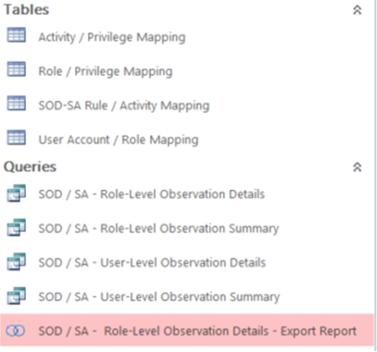
Deloitte will perform this assessment once roles are built to analyze sensitive access and SoD concerns within the new roles. Deloitte will then remediate the issues, based on discussions with the GoA. Once users are assigned to the new roles, Deloitte will perform another assessment to analyze sensitive access and SoD concerns at the user level. The results will be reviewed with the GoA and user access may be adjusted to remediate the issues. If it is determined that the conflicting access is required to perform the user’s job responsibilities, Deloitte will assist in identifying compensating controls to mitigate the risks from the sensitive access and SoD analysis. Deloitte will provide a detailed report describing the analysis performed, potential sensitive access and SoD risks, remediation options and mitigating controls, if any. This report can be used to satisfy security and access control related audit and compliance requirements.
Also included in our approach to business process transformation is the analysis of business process controls, IT general controls, data conversion and interface controls and the development of a control framework. Our approach leverages Deloitte's Risk and Control Knowledge base (RACK), which provides a mapping of expected control objectives and control activities to business processes, as well as automated controls specific to Cloud. The control framework from RACK will be tailored to align with GoA’s key risks and control objectives.

Table below – Controls key objectives, activities and deliverables by phase
Project phase | Key objectives and activities | Deliverables
Plan | The objective of this phase is to understand specific risks and security requirements of the GoA and determine the approach to addressing risks. The key activities in this phase are:  - Assess security and controls risk  - Identify key risks applicable to the GoA  - Develop controls strategy | Controls Strategy
Architect | The objective of this phase is to design the controls framework based on the key risks and the GoA’s control strategy. The key activities in this phase are:  - Review ‘to-be’ business processes and gain input from the Deloitte’s Implementation teams and the GoA as needed  - Develop business process controls framework  - Develop interface controls framework  - Develop IT general controls framework | Draft Control frameworks for interfaces, general computer controls and business control frameworks
Configure & Prototype | The objective of this phase is to validate the completeness of the control framework as the functionalities and security are being configured in the environment. The key activities in this phase are:  - Validate control frameworks with the implementation team and the ’s Control owners
Test | The finalized control frameworks for interfaces, business processes and IT general control areas will be delivered to the GoA. The key activities in this phase are:  - Assist the GoA deploy controls and provide the GoA with controls frameworks that address identified risks | Deliver finalized control frameworks for interfaces, business processes and IT general controls

Deloitte will use the above implementation approach for all sub-components being implemented, in order to assist the GoA with controlling access so as to comply with segregation of duties (SoD), Bill 198 (C-SOX) and other prescribed industry standards. Additional details for some of the sub-components that form part of our solution are below.
Oracle
Oracle security policies cover the management of security for both its internal operations as well as the services Oracle provides to its customers. The policies apply to Oracle employees and customers are strongly encouraged to implement their own comprehensive system of policies, standards and procedures, according to customer risk-based assessments and business requirements. Oracle Security policies are Oracle confidential internal information however, brief summaries of Oracle security policies that may be relevant to Oracle Cloud services.
Oracle’s Corporate Security Solution Assurance Process (CSSAP) is a corporate security methodology designed to provide consistent and proactive information security guidance on projects and initiatives. The process helps projects and initiatives align with:
- Oracle Corporate Security Architecture strategy, direction, and intent.
- Oracle Corporate Information Security policies and procedures.
- Oracle IT Security standards and operational processes.
- Oracle privacy, security and legal requirements.
CSSAP is a comprehensive information security risk management and multi-tiered review process that consists of three types of reviews:
- The Corporate Security Architecture Review Board (CSARB)
- IT Security Technical Review (STR)
- Pre-release security assessments
New Oracle Cloud architecture and changes to deployed environments undergo these reviews, and a record is kept of conditional and non-conditional actions and recommendations. Pre-deployment and post deployment security requirements are also established as part of Oracle’s software assurance process, secure coding standards, build or release criteria, enterprise deployment guidelines, and configuration and change management controls.
Third Party vulnerability assessments and audits - Oracle Cloud may employ third parties to conduct independent reviews of Cloud Services in the following areas (the availability and scope of reports may vary by service and country.):
- Statement on Standards for Attestation Engagements (SSAE) No 16 and Service Organization Control (SOC) 1 and/or 2 reports
- Independent third-party security testing to review the effectiveness of administrative and technical controls
Available reports may be provided to Oracle Cloud customers upon written request. Customers may only use the reports to evaluate Oracle’s security controls. The reports are Oracle Confidential Information under the terms of the agreement between Oracle and the customer under which the customer has acquired the Cloud Service related to the report. The customer may not copy or distribute these reports to their personnel except as necessary. The customer may share these reports with their external auditor, provided that the auditor is bound by confidentiality terms consistent with the customer’s agreement with Oracle, as described previously, and that the auditor uses the report solely to assist the customer in evaluating the controls addressed therein.
Kyriba
Our Risk, Compliance and Contingency department (RCCM) is responsible for ensuring compliance with various external and internal policies. RCCM's compliance procedures include the following:
- Creating and maintaining company security policies & procedures
- Undergoing independent assessments
- Obtain and maintain security certifications
- Educating employees via security awareness training
- Aligning with respected industry security standards (SOC, ISO, C-SOX, SOX etc.)
Our priority is to operate a superior cloud infrastructure that delivers the best treasury management solution. We are aware that security is essential to be successful, and we also recognize the need to be attentive to security levels utilized by our clients. Securing all components of our solution – from physical machines to data and file transmissions – is an ongoing effort and a goal that is core to our organization and operations. Our business model and data content require that we pay the utmost attention to security, and the system has been designed to apply high-level security models, from coding to implementation, which is regularly audited.
Data security measures are pervasive throughout the system, from the hardware deployed and the development methods used through to the internal controls measures supported by the system. They include but are not limited to:
- Maintenance of an internal IT Policy which is regularly reviewed and approved by management.
- Extensive controls governing physical access to the system:
Only limited authorized personnel have access to server rooms or to administration consoles
All employees must wear proper ID badge at all times
Visitors must identify themselves and be accompanied at all times
Biometric controls
Video surveillance
Server bays are locked
Procedures to restrict logical access to the system
Unique identifiers are in place for clients with access to our solution Enterprise. Data stored in the underlying databases is assigned to a client’s unique identifier to restrict access to authorized users.
Our personnel are restricted from viewing or accessing client data unless granted a token issued by the client.
Access to the production environment is restricted to Run Team personnel in order to migrate code to production.
On a quarterly basis, the VP Technical Director reviews the listing of users granted access to the production environment for appropriateness. Access rights are updated as necessary based on the results of the review.
- Electronic tools are in place to monitor and alert unexpected ingress and egress activities, including firewall, intrusion detection/prevention systems (IDS/IPS) and other security devices
- A process for addressing security breaches is documented and disseminated to all relevant individuals (employees, contractors, temps, third-party users), and regular reminders and trainings are also conducted
- Vulnerability testing and monitoring is performed on all external and internal facing systems that manage sensitive and/or critical information
- Client configurable controls within the system
We offer reliable and robust security features built into the application preventing users from accessing entities, bank accounts, settlement instructions, or any fields or functionality that are not included in their security profile. There is no limit to the number of security profiles that can be created and functional access to the entire platform is controlled from the security module.
Access can be granted/restricted both to what the user can do within a function (e.g. read only, read/write, etc.) and to what information they can see (e.g. the client has ten subsidiaries but a user can be granted access to one or a subset of those subsidiaries) relegated within the application.
BravoSolution
BravoSolution complies with the fundamental principles of security management requiring the segregation of duties of all entities involved in this area. As such, distinct and independent third party organizations perform:
- Passive security controls, i.e. assessment of policies, architectures and technologies
- Active security probing, i.e. systematic attempts at obtaining security breaches through ethical hacking techniques by a third party “Tiger team”
The principle of segregation of duties (separation of roles and activities) is strictly applied with respect to roles, responsibilities and activities of the IT area in the processes of application development, environment configuration (Client Solutions), system administration (IT Operations) and safety management. The levels of responsibility are clearly defined both with respect to organizational aspects and with regard to decision-making powers. Proper user profiling also enables a correct mapping of the roles and responsibilities on the technological resources of the system. The mapping of user profiles is subject to annual verification by independent third party organizations. This is done in accordance with the principle of segregation of duties, which requires strict separation between those who “make” the security and those who “control” it.
In accordance with the principle of separation of roles and responsibilities, BravoSolution identifies two distinct and independent figures which are responsible for the security:
- Information Security Officer (ISO):
Responsible for the formalization of new security requirements
Responsible for the "CONTROL" function, which concerns those involved in carrying out the audits and ensure the compliance of the measures already implemented with the ISO27001 system requirements
- Chief Technology Officer (CTO):
Responsible for the "MAKE" function, which concerns those involved in designing and implementing security measures required by the Security Manager and formalized according to business needs.
Within the IT Operations team (IT Ops) several roles have been defined and for each role a specific profile has been defined with access rights for visibility on the various environments used for providing the GoA with BravoSolution’s services:
- Chief Technology Officer (CTO) - Global Head of the IT Operations team (IT Ops) and responsible for the operational management of network and firewall configurations, which are used to create an architecture with separate zones
- SaaS Technology Manager and Web Application Engineer - Responsible for the management (configuration, deployment, etc.) of the application component of the platform devoted to the service delivery
- QA & Technical Support Manager, Software Test Engineer and 2nd Level Support/Implementation Specialist - Responsible for technical support activities relating to operational activities and to test new releases of the software platform
- Senior Database Administrator and Database Administrator (DBA) - Responsible for the administration of the DMBS within the BravoSolution platform
- System Engineer - Responsible for the system management of the hardware and software components of the platform used for basic service delivery to Clients
Within the Client Solutions team (CS) several roles have been defined and for each role a specific profile has been defined with access rights for visibility on the various environments used for providing the GoA with BravoSolution’s services:
- Client Solutions & Security Director - Head of Client Solutions, coordinates pre-sales activities and projects related to the customization of BravoSolution platform and/or the integration with Clients' information systems
- Client Solutions Architect and Software Architect - Carries out projects concerning the design and development of custom application components or concerning the integration of the platform with other systems for individual Clients
- Senior Developer and Developer - Manages the development of custom modules and/or their integration with the Client’s systems
- Global Technical Presales - Responsible for the pre-sale activities for the BravoSolution Enterprise Application Appliance (BSEAA) solution.
- Client Solutions Analyst - in charge of the BravoSolution platform Activation and Configuration Services (SET-UP)
- Web Graphic Manager and Web Graphic Designer - Provides for the customization of the graphic component (‘look and feel’ desired by the Client) during service activation for new Clients
Pervasive user tracing
BravoAdvantage has an extensive mechanism for tracking user activities defined as actions that involve the insertion or modification of data in the database through the use of system records (application logs).
This mechanism is designed to allow analysis of user behavior in relation to specific issues concerning the application.
All key activities performed by users of the system, both internal and external, are associated with relevant time information and with the user identifier, to be stored in special tables in the primary database to ensure the following characteristics:
- Brief description of the activity
- Use of references to identify events of interest
Registration of events relevant to different application areas, for example:
- Access to the system: association of the login credentials to the calling IP address for different sessions
- Online trading: creation, modification, removal, publication, awarding, etc.
- Supplier Register: insert, modify and ranking of suppliers
- Registration: registration, user management
Each line in the log contains the following information:
- Time reference
- User’s session identification code
- User ID: identifier of the single user
- Account ID: unique identifier of the registered organization
- Object Code: identification code of the trading or purchasing event
- IP address
- Activities undertaken
The information that is used to compose a single line of the application log is all that is necessary and sufficient to reconstruct each user action in relation to the platform. Specifically, the structure of the single line of log is such that you can filter and isolate the sequence of operations that you want to be highlighted by applying the appropriate filter operators, e.g. the calling IP, the application session, or the User ID. The payload part of the single line of log lists, in natural language, the operation performed by the user. For each line of log there is a timestamp referring to a standard ITU (International Telecommunication Union) time.

Table K |  | Security and controls
4.0 | Cloud Security Standards
The Province has implemented Cloud security standards for the storage of GoA information. This standard defines the controls which should be used for all GoA data and information in Cloud environments:
- All GoA Information Security Management Directives (ISMDs) and GoA security standards apply to Cloud Services. Any services transitioned to, or created in Cloud environments should meet or exceeded security controls and provisions set out in ISMDs and security standards.
- All data migrated to, or created in Cloud Services should be classified as per the GoA information security classification standard before migration or creation.
- Legislative and regulatory requirements specific to Departments should be taken into account and complied with in addition to the controls listed in this standard. In cases where legislation/regulations conflict with this standard, the legislation/regulations will take precedence.
- Any applications or projects moving protected information and data to Cloud Services should complete an STRA (Security Threat and Risk Assessment) prior to implementation.
- Public information can be stored in Cloud Services without restrictions; however, the information controller may have integrity and availability requirements which should also be considered.
- In order to ensure control of access, any Cloud service hosting protected information and data should be architected to ensure that the GoA controls the provisioning and revocation of all credentials used to access the service. Administrative access to the data should always be maintained by the GoA.
- Cloud service providers should be given express contractual consent from the GoA to conduct any analytics on data with a protected classification subject to specific written authorization from the Province.
The Proposal should:
- describe how the ERP Solution aligns with the above Cloud security Standards;
- describe how the Cloud Services enable the GoA to manage all major milestones of data and information that GoA will store in the Cloud service to ensure integrity including creation/collection, classification, organization, use, storage, retention, and disposition; and
- describe how all GoA records residing within the Cloud service have the ability to be replicated or backed up and be accessible to the GoA in the event the Cloud service becomes inaccessible (e.g. due to a disaster event, termination of service) based on GoA’s business continuity requirements.
Pre-Qualified Proponent Comments:
  - describe how the ERP Solution aligns with the above Cloud security Standards
The component parts of the Deloitte solution (i.e. Oracle, Kyriba, BravoSolution, SchedulePro, GenTax) provide leading controls to safeguard data for the Province of Alberta. These controls include:
- Alignment with security standards such as ISO and IEC
- Third party audits of their internal controls based on SSAE16
- Strong password policies on infrastructure components and cloud management systems used to operate the Cloud environment
- Security Oversight Committee or similar governance structure to review and approve the Vendor’s security and privacy policies and programs
In addition, Deloitte and our vendor partners will establish non-disclosure agreements (NDA’s) with the GoA to formalize our commitment to protect the Province’s data.
Details for the sub-components that form part of our solution are below.
Oracle
Oracle has adopted security practices for Oracle Cloud Services that are designed to protect the confidentiality, integrity, and availability of customer information. The security practices for Oracle’s Software as a Service (SaaS) Cloud services reflect Oracle’s formal security policies, including:
Oracle information security
Oracle security policies cover the management of security for both its internal operations as well as the services Oracle provides to its customers. The policies apply to Oracle employees and customers are strongly encouraged to implement their own comprehensive system of policies, standards and procedures, according to customer risk-based assessments and business requirements. Oracle Security policies are Oracle confidential internal information however, brief summaries of Oracle security policies that may be relevant to Oracle Cloud services are provided below.
Organization of information security
The Oracle Security Organization Policy describes the roles and responsibilities of various teams and individuals involved in information security at Oracle, including the executive-level oversight committee, corporate Information, Product, and Physical Security organizations, Information Technology (IT) and IT Security organizations, Lines of Business (LoBs), and individual Information Security Managers (ISMs) who are assigned by each LoB to represent the security leadership of each organization.
The Oracle Information Security Policy describes the principles for development, executive approval, implementation, and maintenance of information security policies and practices at Oracle. This over-arching information security policy also describes governing principles such as 'need-to-know', least privilege, and segregation of duties. Employees, contractors and temporary employees are subject to Oracle security policies.
Human resource security
The Oracle Code of Ethics and Business Conduct sets forth Oracle's high standards for moral ethics and business conduct at every level of the company and at every location where Oracle does business throughout the world. The standard applies to employees, independent contractors, and temporary employees and it covers the areas of legal and regulatory compliance, business conduct and relationships.
Communications security
The Oracle Network Security Policy states that computers, Servers, and other data devices connected to the Oracle network must comply with security policies and standards for security, configuration, and access methods.
Operations security
The Oracle Server Security Policy sets forth the physical and logical security requirements for Internet-facing and production servers.
The Oracle Logging and Log Analysis Policy states corporate-level mandates for log retention, review, and analysis. Areas covered include minimum log requirements, responsibilities for the configuration and implementation of logging, alert review, problem management, retention, security and protection of logs, as well as compliance review.
The Oracle Secure Socket / Transport Layer Policy requires TLS v1.1 or later SSL enablement for Web-based applications.
Access control
The Oracle Logical Access Controls Policy describes logical access control requirements for Oracle systems, including authentication, authorization, access approval, provisioning, and revocation for employees and any other Oracle-defined 'users' with access to Oracle systems that are not Internet facing publicly accessible systems.
The Oracle Password Policy requires protection of information assets by Oracle employee use of strong password controls where passwords are being used as a method of authentication. Password expiration and reset requirements are enforced.
System acquisition, development and maintenance
The Oracle Critical Patch Update and Security Alert Implementation Policy requires implementation of Critical Patch Updates (CPU) and Security Alert fixes, as well as associated recommendations, within a reasonable time of their publication.
The Oracle Media Sanitization and Disposal Policy establishes guidelines for secure erasure of information from electronic media, where current usage of the media is finished and a decision is made regarding recycling or destruction. The policy is intended to protect Oracle resources and information from security threats associated with the retrieval and recovery of information on electronic media.
Incident management
The Oracle Information Security Incident Reporting and Response Policy requires reporting of and response to information security incidents in a timely and efficient manner. Oracle also maintains a detailed Information Security Incident Response Plan to provide specific guidance for personnel involved in or supporting incident response. This policy also provides requirements for Oracle employees to notify identified contacts internally in the event of suspected unauthorized access to personal information or customer data.
Information security aspects of business continuity management
Oracle has a global Risk Management and Resiliency Program (RMRP) that serves to meet Oracle’s corporate resiliency requirements. The RMRP comprises planning and testing of Oracle’s critical internal operations.
Security awareness and training
Oracle promotes security awareness on a company-wide basis and educates personnel through quarterly newsletters, ad-hoc security awareness campaigns, and security-related corporate email notifications. All Oracle personnel are required to complete an information protection awareness training course upon employment, and ongoing throughout their tenure. The course instructs personnel on their obligations under the various central Oracle privacy and security policies. The course also trains personnel on data privacy principles and data handling practices that may apply to their jobs at Oracle and are required by the company policy, including those related to notice, consent, use, access, integrity, sharing, retention, security, and disposal of data. All new Oracle personnel are also required to complete training in corporate ethics. Additionally, personnel involved in development of custom code are required to attend secure coding training.
Kyriba
Our standard authentication model requires the use of a unique UserID and password. We support strong password controls such as timeouts, mandatory resets, alphanumeric requirements, and the Kyriba Virtual Keyboard, all of which can be set up to meet treasury and corporate IT policies.
We offer reliable and robust security features built into the application preventing users from accessing entities, bank accounts, settlement instructions, or any fields or functionality that is not included in their security profile. There is no limit to the number of security profiles that can be created and functional access to the entire platform is controlled from within the application.
The GoA owns all system administration. Access can be granted/restricted both to what the user can do within a function (e.g. they have access to the electronic payments functionality but can only request a payment and not approve one) and to what information they can see (e.g. the client has ten subsidiaries but a user can be granted access to one or a subset of those subsidiaries) relegated within the application.
Isolation of data for each customer is based on the concept of data segregation that provides a Virtual Private Data Domain (VPDD) to each customer. We are using a specific mechanism called 'data segregation' based on a data domain unique identifier. Each customer has their own unique data domain identifier. This mechanism can’t be overridden by any functional code. Each customer data request automatically includes a complementary filter based on this unique identifier. This mechanism is used in conjunction with standard referential integrity.
BravoSolution
The scope of the BravoSolution ISMS is defined as: “The Information Security Management System (ISMS) supporting the provision of BravoSolution SaaS (Software as a Service) and BravoSolution EAA (Enterprise Application Appliance) solutions for enterprise supply management processes.”
This scope includes the activities of Client Solutions and IT Operations staff providing these services.
The following sections enumerate the various components of the ISMS scope in terms of the following:
- The relevant activities within the SaaS processes and services within the scope of the ISMS
- The relevant activities within the EAA processes and services within the scope of the ISMS
- The staff carrying out these activities
- The organisational boundaries, including both internal third parties relied upon for providing supporting information security aspects, and external third parties that provide specialist services under contract
- The physical locations involved, including both staff locations and relevant equipment locations
- IT systems developed / deployed / managed / used only by SaaS solutions staff in the course of their work
The different types of information that are processed, stored and communicated by IT systems (at a level relevant to the SaaS processes), and the types of information handled directly by SaaS process staff in the course of their work, is documented in a separate Information Asset Register for the recommended scope.
A complete description of the ISO27001 scope has been detailed within the following documents:
- Information_Security_Perimeter.doc
The information security perimeter consists of three interrelated dimensions:
- Organizational dimension
- Physical dimension
- Logical dimension
The information security perimeter defines the scope of the information security management system (ISMS) adopted by BravoSolution in conformity with the ISO 27001 standard.
BravoSolution complies with the fundamental principles of security management requiring the segregation of duties of all entities involved in relevant security domains.
The principle of segregation of duties (separation of roles and activities) is strictly applied with respect to roles, responsibilities and activities of the IT area in the processes of application development, system administration (operations) and safety management. The levels of responsibility are clearly defined both with respect to organizational aspects and with regard to decision-making powers. Proper user profiling also enables a correct mapping of the roles and responsibilities on the technological resources of the system. The mapping of user profiles is subject to annual verification by independent third party organizations. This is done in accordance with the principle of segregation of duties, which requires strict separation between those who “make” the security and those who “control” it, as described in detail in the ISO 27001 documentation.
BravoSolution has undergone full third party security assessments of the entire infrastructure underlying BravoAdvantage SaaS delivery.
These independent evaluations are generally performed following the open source methodology evaluations. This has been performed by means of the OSSTMM methodology (http://www.isecom.org/research/osstmm.html) or with the direction of following other third party methodologies. 10-15 internal and external vulnerability scans and penetration tests are performed annually. The results of these support BravoSolution's continued dedication to information security.
SchedulePro
SchedulePro is offered as a cloud service, fully hosted and supported in Canada. All configuration and management of the service is handled by EDP Software. As part of the ongoing service fee, new versions of the software will become available to all users when they are ready. In the SaaS delivered system, upgrades are managed by EDP.
EDP guarantees that any software enhancement created for GoA will be available in subsequent releases. EDP provides early access test environments to customers so they can ensure that any new versions of the product continue to function.
GenTax
The GenTax solution will be hosted by Oracle and therefore the processes and controls described under the Oracle section above will apply.
  - describe how the Cloud Services enable the GoA to manage all major milestones of data and information that GoA will store in the Cloud service to ensure integrity including creation/collection, classification, organization, use, storage, retention, and disposition
Our deep expertise in privacy
Our privacy team – which consists of experienced privacy professionals, project managers, and privacy lawyers – has deep experience working with public sector organizations, planning for legislative changes involving new collections and uses of data, and implementing new programs that involve sensitive data assets governed by privacy legislation, particularly Ontario’s PHIPA and FIPPA. Deloitte has had the opportunity to work with various Information and Privacy Commissioner Offices across Canada. Most recently, Deloitte worked with the former Ontario Information and Privacy Commissioner to develop the “Privacy by Design” assessment methodology. This harmonized framework operationalizes the core privacy principles that form the backbone of Canadian and Ontario privacy law, and can be used to embed privacy into any strategy or transformation from the ground up. Deloitte’s leadership in privacy enables us to assign qualified, knowledgeable and industry-respected personnel to work alongside our clients using an approach that is advisory and but also about continuous knowledge transfer. Members of the proposed advisory team have not only conducted dozens of privacy program assessments and privacy risk reviews and implemented privacy programs, but have facilitated privacy and security strategy sessions and workshops to integrate any findings into transferable ‘lessons learned’ for a variety of public sector clients.
Deloitte’s Data Protection and Privacy (DPP) practice in Risk Advisory
Deloitte provides clients with privacy and security consulting and advisory services through our Data Protection and Privacy practice. We have more than 15 years of privacy and security experience. Our team offers an end-to-end portfolio of services to help our clients manage data protection risks across the enterprise and develop tailored privacy, security, and regulatory requirements for new initiatives and endeavors.
Our privacy team – which consists of experienced privacy professionals, project managers, and privacy lawyers – has deep experience creating privacy frameworks and conducting privacy analyses on changing privacy laws across jurisdictions. Deloitte has worked closely with various Information and Privacy Commissioner Offices across Canada. Deloitte has also worked with national and provincial funding bodies to establish privacy and security requirements for eHealth systems, privacy and security frameworks, and privacy and security tools.
Our team has extensive experience, not only creating requirements and standards for certification or benchmarking purposes (including Privacy by Design, the Generally Accepted Privacy Principles, PIA guidelines for the Ontario IPC and for the Treasury Board Secretariat, and ISO standards harmonization), but also tailoring our approaches to each client, initiative, technology, and jurisdiction. Our cross-disciplinary services help our clients to manage privacy risk, comply with privacy legal and regulatory requirements while at the same time, position organizations for embarking on new and innovative solutions and programs in a privacy compliant way.
Deloitte has a proven reputation for delivering practical, top-quality, privacy solutions in support of our clients’ business goals. Independent analysts consistently rate Deloitte as a global leader in the security and privacy consulting and technology risk management space. Gartner ranked Deloitte #1 for Risk Management Consulting Services Worldwide in 2015.
Deloitte works with numerous government organizations in the areas of privacy legal advisory services, privacy and cyber security strategy development, data protection program development and implementation. Our experience providing a range of services in the areas of privacy and security risk management, privacy strategy and roadmaps, regulatory and legal requirements mapping and benchmarking, will all serve to inform our GoA’s engagement approach.
The following diagram outlines our full suite of data protection and privacy offerings, which we have applied over years of experience with dozens of public sector clients:
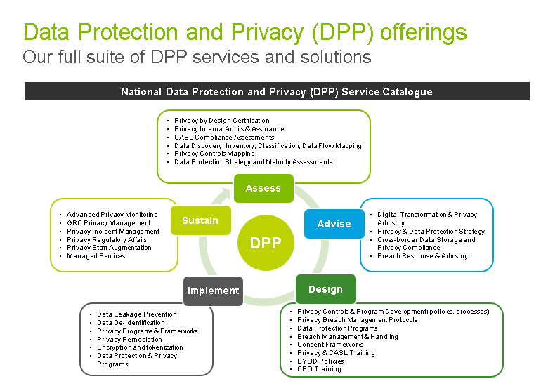
We will leverage our own privacy and security controls framework, based on the concept of Privacy by Design, as part of our design and assessment of the solution. Our PRA is based on the 7 foundational principles of Privacy by Design which include a well-defined set of privacy criteria and illustrative controls Deloitte developed and that our team will look for to identify and mitigate against privacy and security risks. These privacy and security criteria and controls we will benchmark solutions against will reflect applicable privacy legal requirements and industry standards and privacy best practices, including for example:
- Canada’s federal Personal Information Protection and Electronic Documents Act (PIPEDA)
- Canadian Standard Association’s Model Code for the Protection of Personal Information (CSA Model Code)
- Generally Accepted Privacy Principles (GAPP) developed by the Chartered Professional Accountants of Canada (CPA), and
- Relevant orders and guidelines from the federal and provincial Information and Privacy Commissioners that are high-risk items which should be considered from the onset of any platform or strategy design.
Deloitte works with across a variety of industries, nationally, in the areas of privacy legal advisory services, privacy strategy development, data protection program development and implementation. We also provide services in the areas of privacy risk management, privacy crisis management, privacy policy development and implementation, staff privacy education and training, and the application of privacy laws and “best practices” relating to the collection, use and disclosure of personal information.
Privacy impact assessment
A PIA is a specialized tools used to measure privacy risks associated with specific projects or systems; examine the impact to privacy and the handling of personal information as a result of a business change (e.g. PIA).
A PIA outlines specific questions about data collection, use, and disclosure activities for the purposes of identifying and mitigating privacy risks associated with a specific project or system. PIAs address specific initiatives. A privacy audit is a tool used to determine if an organization is complying with its own privacy policies, and legislative requirements. Some of the components include an audit plan, risk assessment, testing and evaluation of control weaknesses.
In so doing, the PIA describes:
- System design choices
- Data flows and individual control over personal information
- Legislative authorities for the collection, use and disclosure of personal information
- Safeguards to protect personal information
- Risks and recommendations
Conducting a PIA
- Clearly define scope in advance
- Choose and define a template that will work for GoA
- A team approach – the process needs a combination of privacy knowledge and detailed program knowledge
- Sensitivity to other demands
- Program area collects documentation
- Document collection, use, disclosure, retention and destruction (information management lifecycle should be mapped to legal authority where applicable and best practice)
- Identifying a lead
- Key considerations
- Budget, time, knowledge
- Involving management – the corporate view, strategic direction
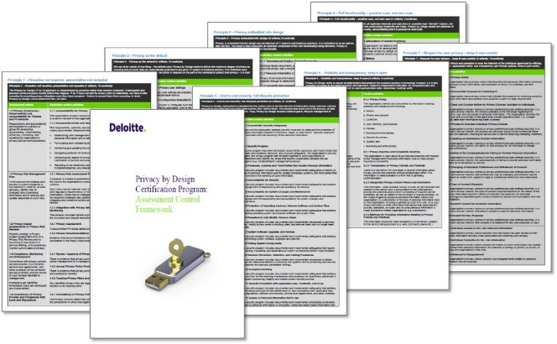

Privacy by design assessment
Methodology:
Benchmarked against the seven Foundational Principles of privacy by design by following three steps:
- Conducting interviews with key personnel
- Reviewing current system design controls and information handling practices (from collection to disposition), and
- Providing a report of the results to management
The seven Foundational Principles of privacy by design include:
- Proactive not reactive; preventative not remedial
Privacy as the default
Privacy embedded into design
Full functionality—positive-sum, not zero-sum
End-to-end lifecycle protection
Visibility and transparency
Respect for user privacy
Data flow mapping
Description of the service:
It is recommended and as a best practice in Canada, that a data mapping exercise be undertaken. This activity enables an end-to-end understanding of how PI is collected, used, disclosed, processed and stored by company.
Key activities & deliverables:
- Through interviews and documentation review, gain an understanding of the flow of PI across the organization, collection points, disclosure points, where it is stored and the controls in place to protect the PI. Based on this understanding, we will create visual depictions of the data flows (through Visio) and create an inventory of PI. All data maps will be validated with business units.
- Draft a policy/procedure for sustainment of data maps and inventory
- Incorporate any additional findings into the implementation roadmap
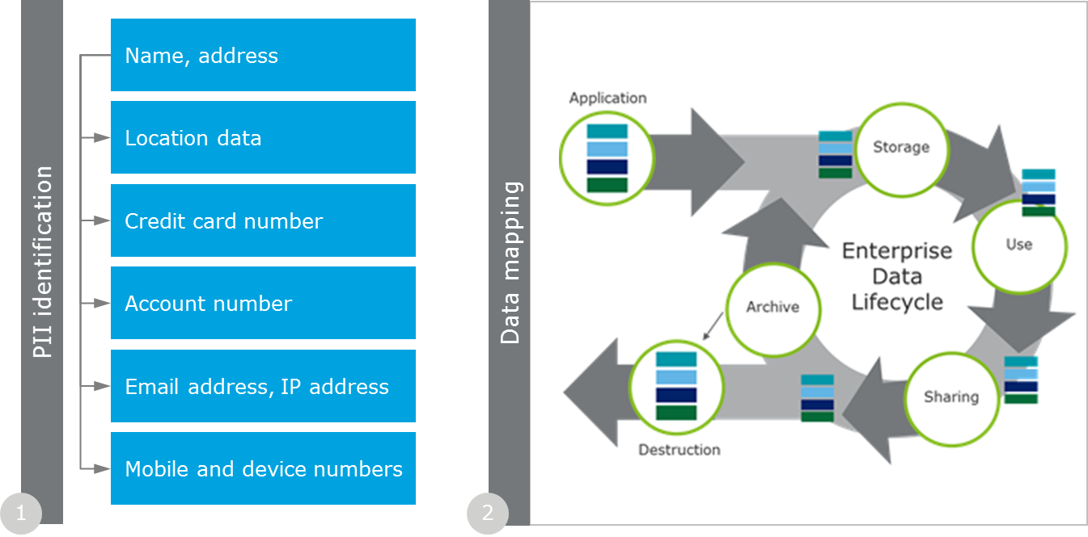
  - describe how all GoA records residing within the Cloud service have the ability to be replicated or backed up and be accessible to the GoA in the event the Cloud service becomes inaccessible (e.g. due to a disaster event, termination of service) based on GoA’s business continuity requirements.
Details for the sub-components that form part of our solution are below.
Oracle
Oracle Cloud Services maintains a redundant and resilient infrastructure designed to maintain high levels of availability and to recover services in the event of a significant disaster or disruption. Oracle designs its cloud services using principles of redundancy and fault-tolerance. Oracle Cloud Services provide an infrastructure that incorporates a comprehensive data backup strategy. The Oracle Cloud includes redundant capabilities such as power sources, cooling systems, telecommunications services, networking, application domains, data storage, physical and virtual servers, and databases.
For covered Cloud Services, Oracle has two separate data centers that function as primary and secondary sites. Customer’s production standby (secondary site) environment will reside in a data center separate from Customer’s primary site. Oracle will commence the disaster recovery plan under this Policy upon its declaration of a disaster, and will target to recover the production data and use reasonable efforts to re-establish the production environment at the secondary site. For a major regional jurisdictional area (e.g., Canada, the United States or the European Union), Oracle operates both a production and secondary site within that region. Customer data is replicated in physically separate facilities in order to restore services in the event of a disaster at a primary site. Backups are for Oracle's sole use in the event of a disaster.
Oracle provides for the recovery and reconstitution of its production Cloud Services to the most recent available state following a disaster. Oracle has established alternate processing sites to accommodate full operating capability in the event of loss of service at a primary facility. Oracle maintains a Disaster Recovery Plan that describes recovery procedures. Disaster recovery operations apply to the physical loss of infrastructure at Oracle facilities. Oracle reserves the right to determine when to activate the Disaster Recovery Plan. During the execution of the Disaster Recovery Plan, Oracle provides regular status updates to Customers.
Kyriba
The backup configuration of our data centers ensures the security of your data in case of an incident or disaster. Both data centers within each of our North American and European infrastructures are active (See Figure below). Each server at each data center is replicated at the other data center using secure connections and dedicated replication appliances. In this backup configuration, servers from data center A are replicated on a second infrastructure at the data center B and vice versa.
In addition, incremental backups of all data and the application are performed to a local backup appliance on a daily and weekly basis and full backups are performed on a monthly basis. Backups are additionally replicated to a remote Disaster Recovery appliance housed at the alternate data center. On a daily basis the Technology and Operations Team reviews the status of the backups to ensure successful completion of the backups. Approximately every six weeks, Technology and Operations Team personnel restore the most recent backup to a test environment to ascertain the integrity of the backup data.
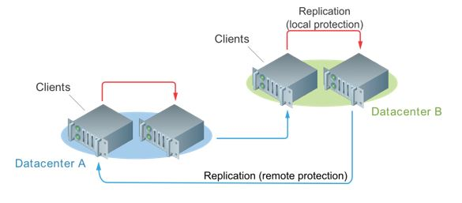
Upon termination, all terminated client data remains protected and secured as all other client data stored in our production systems. This is in alignment with other SaaS industry providers’ best practices currently in place.
The client database is marked as "inactive" in order to prevent further access to the application upon termination of the contract. This is done at an internal application business console level. Tokens that allow access of client end users to the client database are deleted at both the user and client level. All scheduled activity and communications for this client are removed.
While the contract is in effect, and if negotiated, for a reasonable time after actual termination of the contract, the client's data can always be extracted by the client themselves using tools and reports built into the application.
BravoSolutions
With respect to GoA records residing with the cloud, the BravoSolution solution is ISO 22301: 2012 certified. This certification – assigned by Intertek, UKAS member – allows BravoSolution to be prepared in the face of the significant disruptions from outside threats such as a natural disasters or information security breaches. This new ISO 22301 certificate has been obtained on the integrated system already certified on ISO 20000-1 and ISO 27001. This means that BravoSolution is able to provide: Guaranteed Service Levels – Performance, Maintenance, Continuity & Certified Information Security – Confidentiality, Availability, and Integrity.
BravoSolution data centers have fully redundant power supply with full balancing of the lines in order to guarantee power supply continuity in case of critical path failure through diesel generators in N+1 configuration.
SchedulePro
SchedulePro hosting environment is fully redundant with both a primary and geographically separated secondary data center. There is no single point of failure and in the unlikely case of complete data center failure, EDP Software can switch to a secondary data center for disaster recovery and ensure continued operations. Backups occur automatically (data and operating systems), and are stored in our secondary data center.

GenTax
The GenTax solution will be hosted by Oracle and therefore the processes and controls described under the Oracle section above will apply.

Table K |  | Security and controls
5.0 | Privacy
The Proposal should:
- describe the Pre-Qualified Proponent's privacy control, general audit practices used in development, implementation and operations, including but not limited to:
- who audits the Solution;
- the frequency of the audits;
- any audit standards used in the audit; and
- any audit certifications awarded.
Pre-Qualified Proponent Comments:
  - describe the Pre-Qualified Proponent's privacy control, general audit practices used in development, implementation and operations, including but not limited to:
- who audits the Solution;
- the frequency of the audits;
- any audit standards used in the audit; and
- any audit certifications awarded.
Deloitte has one of the largest security practices in Canada that we would leverage for the benefit of GoA. Recently Deloitte’s Security Practice was awarded a 5-year contract to provide Managed Security Services for a leading Pension provider that we believe is a key differentiator. At the start of the engagement, Deloitte will work with GoA Security & I&IT to provide SOC controls that conform to ISO27001 standards, regulatory guidelines and GoA’s Information Security policies. This includes but not limited to the following:
- Security Governance: includes roles and responsibilities, escalation processes and monitoring to be used to surface all security- and privacy-related risks, issues and priorities
- Logging & Monitoring: Logging and monitoring of user access and user activity to safeguard privacy and security and maintain client confidentiality of data
- Security & Privacy Incident Management: Due to the sensitive nature of the data stored within the Province’s systems, incidents involving breaches in integrity (i.e. unauthorized access to or altering of records), in particular the improper disclosure of personal information stored in the system, will be managed via our Incident Management process. We will review and refine this plan with the Province during the start of the project to ensure security and privacy incidents are appropriately identified, responded to and reported on.
- Security Controls: Deloitte will review and align their security and controls with your existing data center and application security and controls, to include such as encryption of all data through transformation and transition to third-party data centers
Details for the sub-components that form part of our solution are below.
Oracle
The Services Privacy Policy describes Oracle’s treatment of data that resides on Oracle, customer, or third-party systems (including personally identifiable information or “PII”).
Oracle Cloud Services operate under Policies which are aligned with the ISO/IEC 27002 Code of Practice for information security controls, from which a comprehensive set of controls are selected, as described by ISO/IEC 27001.
The internal controls of Oracle Cloud Services are subject to periodic testing by independent third party audit organizations. Such audits may be based on the Statement on Standards for Attestation Engagements (SSAE) No. 16, Reporting on Controls at a Service Organization (“SSAE 16”), the International Standard on Assurance Engagements (ISAE) No. 3402, Assurance Reports on Controls at a Service Organization (“ISAE 3402”), or such other third party auditing standard or procedure applicable to the specific Oracle Cloud Service. Audit reports of Oracle Cloud Services are periodically published by Oracle’s third party auditors, although reports may not be available for all services or at all times. Customer may request to receive a copy of the current published audit report available for a particular Oracle Cloud Service.
Different audit reports and tests have different cadences but no less than annual. For example SOC-2 reports have a typical cadence of every six (6) months. SOC and auditing reports can be requested by customers at any time.
Kyriba
Our platform is audited on an annual basis to ensure it meets the SSAE 16/SOC1 and SOC2 standards. The SOC 2 Type 2 certification, defined by the American Institute of Certified Public Accountants (AICPA), is recognized worldwide as one of the strictest audit standards for service providers. This certification has been designed to meet the needs of the growing number of IT and cloud computing companies. It allows the audited organization to demonstrate that it meets and exceeds the industry's accepted standards governing controls and protection of all hosted and processed data, on behalf of our clients.
As apart of the annual SOC 2 Type 2 certification from the auditors, We are required to be tested on each of the 5 principals, those being: Security, Availability, Processing Integrity, Privacy, and Confidentiality. Additionally, SIG7 requirements mandate monthly status and review of Information Security assessment plans and remediation project lists.
Our risk assessment process, is performed by management on an ongoing basis, to identify and manage risks that could affect our ability to provide reliable service to its clients. Business and IT plans are created each year that establish priorities and allocate resources to address those priorities. This process requires management to identify significant risks and to implement appropriate measures to manage these risks. The following identified risks are not intended to be all-inclusive:
- Operational risk associated with computerized information systems and the manual process involved in system configurations
- Reputational risk associated with reliance on external parties for receipt or delivery of data and hosting services
We have a common methodology for all risk assessments and provides specific process steps. The high level steps are as follows:
- Prepare for Assessment
- Conduct Assessment
- Analyze and Report Results
- Create Risk Mitigation Plan
- Communicate Results and Risk Mitigation Plan to Business Owners
- Meet with Business Owners to status risk mitigation plan
- Final Closeout once Plan has been fully implemented
We have implemented a robust Risk Management Framework to manage its security risks which depicts a security risk management life-cycle, and sets the requirements for understanding, assessing, responding, and monitoring security risks.
Our security program is built on security pillars of success:
- A library of security policies and procedures
- Risk Management program
- Annual global security awareness training
- A Security compliance program for company certifications, audits, and regulatory requirements
- Secure coding training and practices
- Alignment with industry best practices
Our risk assessment methodology is based on:
ISO/IEC 27001:2013
ISO/IEC 31000 and 31010 Risk Management
To add additional detail and structure to the ISO standards, We have also incorporated NIST risk assessment controls as detailed below:
NIST SP 800-30, Guide for Conducting Risk Assessments
NIST SP 800-39, Managing Information Security Risk: Organization, Mission, and Information System View
NIST SP 800-115, Technical Guide to Information Security Testing
We undergo various independent third party assessments and security testing against the application and infrastructure to ensure that its security controls are implemented properly and operating effectively. The results from these tests are made available to existing and prospective customers who are under NDA, in order to provide them with the assurance and validation that our security controls are in line with their stated controls and policies. Although Customer and Prospect penetration testing is not preferred due to added resource strain, duplication of effort, and possible risk, We can accommodate additional security testing requests from a customer/prospect, providing specific procedures are followed. These can be provided to GoA upon request.
BravoSolution
The policy for the Privacy Management System (PMS) adopted by BravoSolution and approved by the ISO Steering Committee has been defined according to BravoSolution business context and Privacy principles stated in both ISO 29100 and ISO 27018 standards in order to:
- Manage all BravoSolution privacy issues
- Address the processing of Principal PII
- Drive, monitor and control all privacy aspects concerning BravoSolution operational activities related to the services delivered
In this context, ISO 27001 Information Security Policy, ISO 20000-1 Service Policy and ISO 22301 Business Continuity Policy are related to ISO 27018 Privacy System Policy in order to address:
- All PII processed according to BravoSolution business model
- Contractual requirements and Service Level Agreement related to privacy issues
- Business continuity requirements and objectives related to privacy issues
Audits are conducted by independent third parties in accordance with maintaining the following ISO accreditations as well as auditors acting on behalf of our clients.
Audit Certifications Awarded
- ISO 9001
- ISO 20000-1
- ISO 22301
- ISO 27001
- ISO 27018
BravoSolution has been formally audited and certified compliant with the ISO27001 standard by Moody International, accredited by the UKAS (United Kingdom Accreditation Service).
BravoSolution has met all the key requirements of ISO/IEC 27001:
- Systematic examination of the organization's information security risks, taking into account threats, vulnerabilities and impacts
- Design and implementation of a coherent and comprehensive suite of information security controls
- Adoption of a comprehensive management process which ensures that the information security controls continue to meet the organization's information security needs on an ongoing basis
The establishment, maintenance and continuous update of the ISMS demonstrate how BravoSolution is using a systematic approach for the identification, assessment and management of information security risks. BravoSolution is capable of successfully addressing information confidentiality, integrity and availability requirements.
SchedulePro
Audits will be supported as required by GoA and results will be made available. The cost of supporting any audit activities will be charged at standard consulting services rates.

Table K |  | Security and controls
6.0 | Security Classification
The Proposal should:
- describe the ability of Software to align data security controls with the information security classification of electronically stored information (ESI).
Pre-Qualified Proponent Comments:
  - describe the ability of Software to align data security controls with the information security classification of electronically stored information (ESI).
Our Data Protection and Privacy practice offers an end-to-end portfolio of services to help our clients manage data protection risks across the enterprise. These services are designed to address privacy risks to all types of assets, including the convergence of people, process and technology risks covered by Privacy Risk Assessments (PRAs). As a leader in privacy, Deloitte has conducted hundreds of PRAs, authority analyses, and privacy reports as well as developed and implemented dozens of organizational and initiative specific privacy programs Canada-wide.
Deloitte works with across a variety of industries, nationally, in the areas of privacy legal advisory services, privacy strategy development, data protection program development and implementation. We also provide services in the areas of privacy risk management, privacy crisis management, privacy policy development and implementation, staff privacy education and training, and the application of privacy laws and “best practices” relating to the collection, use and disclosure of personal information.
Deloitte has developed a Privacy by Design Controls Matrix aligned to the internationally recognized 7 Foundational Principles of Privacy by Design developed by Dr. Ann Cavoukian, Ontario’s former Information and Privacy Commissioner. The concept of Privacy by Design means building privacy into the design, operation and management of IT systems, networks and business processes. To help organizations operationalize the 7 Foundational Principles through people, process and technology controls, Deloitte has built a controls framework that aligns international privacy legal requirements, industry best practices, standards (GAPP, ISO/IEC 29100, ISO/IEC 2700, ENISA), regulatory guidance and security standards to the concepts of Privacy By Design. We have drafted a total of 107 controls across 30 assessment criteria areas, which map back to the principles of Privacy by Design. To this end, Deloitte has developed the Privacy by Design Certification Program with Ryerson’s Big Data and Privacy Institute and the former Ontario Privacy Commissioner, to help clients launch new products and services through privacy enhancing technologies and expand their digital footprint.
Approach
We will leverage our own privacy and security controls framework, based on the concept of Privacy by Design, as part of our design and assessment of the solution. Our PRA is based on the 7 foundational principles of Privacy by Design which include a well-defined set of privacy criteria and illustrative controls Deloitte developed and that our team will look for to identify and mitigate against privacy and security risks. These privacy and security criteria and controls we will benchmark solutions against will reflect applicable privacy legal requirements and industry standards and privacy best practices, including for example:
- Canada’s federal Personal Information Protection and Electronic Documents Act (PIPEDA)
- Canadian Standard Association’s Model Code for the Protection of Personal Information (CSA Model Code)
- Generally Accepted Privacy Principles (GAPP) developed by the Chartered Professional Accountants of Canada (CPA), and
- Relevant orders and guidelines from the federal and provincial Information and Privacy Commissioners that are high-risk items which should be considered from the onset of any platform or strategy design
The concept of embedding privacy and security into the GoA’s solution, strategy and vision will help ensure that the GoA’s is in compliance with its privacy legal obligations, and avoid the GoA from having to retrofit its solution in the future, which can be more costly. Ultimately, this approach will augment the value proposition of the GIA Managed Security Services (MSS) by building public confidence and trust upfront, and preventing the risk of privacy breaches.
Our privacy by design controls framework is built on three key control areas that will be considered during our review of the solution as well as the GoA overall strategy, including:
- People - This area includes the assessment of common pitfalls and issues arising from lack of governance and accountability, employee awareness, management support, availability of guidelines and manuals, and mechanisms for communicating information handling and data protection practices.
- Process/Data Flows – This area includes an assessment of the nature and type of information collected and the associated sources and purposes for obtaining the information, how data protection is ensured operationally throughout the data lifecycle, from cradle to grave, and what mechanisms are in place to safeguard the information. For this, Deloitte will conduct a current state data mapping and data flow analysis, that focuses on: (a) the sources of data; (b) the systems/applications and workflows used to process/analyze, manage, and store data; and (c) how data is accessed/shared internally and externally with member organizations and other third parties, as well as what controls are in place to protect personal information.
- Technology – This area includes an analysis of system design characteristics, system interaction, personal data security and integrity measures, logical access controls, segregation of duties, logging and audit trails, data loss prevention capabilities, and other relevant technical controls to prevent unauthorized access to information and data leakage, as appropriate.
- Governance – This area includes setting the tone from the top, developing an accountability framework and organizational culture to demonstrate how privacy is top of mind and aligned with strategic objectives and embedded into day-to-day operations.
The privacy control framework is based on privacy legal requirements (e.g., PIPEDA), industry best practices and privacy standards (e.g., GAPP, ISO/IEC 29100, ISO/IEC 2700, ENISA), including regulatory guidance issued by the FTC and Privacy Commissioners (e.g. FTC IoT Privacy and Security in a Connected World, OPC Getting Accountability Right with a Privacy Management Program).
Hands-on experience. Before beginning their consulting careers, our data protection professionals worked in staff roles as Chief Privacy and Security officers in the public and private sectors.
Security leadership. Forrester has named Deloitte a Leader in their Forrester Wave: Information Security Consulting Services, Q1 2013 and notes “Deloitte's ability to execute rated the highest of all the participants.” Additionally, Deloitte was the leader in “Current offering”.
Deloitte will leverage the above methodology for all sub-components being implemented, in order to assist the GoA with aligning data security controls with the information security classification of electronically stored information (ESI). Additional details for some of the sub-components that form part of our solution are below.
BravoSolution
The figure below shows a schema to describe the information mapping according to the confidentiality and the level of availability to the public of the data, and how data are stored within the BravoSolution platform independently by the nature of the support (files and records).

Figure K6 — BravoSolution Platform information mapping
BravoSolution has adopted a Compliance Management System according to standard ISO 19600 in order to manage all compliance issues concerning his business context. With respect to the context of activities performed and information or data processed through the platform, BravoSolution has inserted the specific tracking and compliance check of the following legal requirements:
- eCommerce
- Public procurement
- Privacy (personal data protection)
- Corporate Liability
eCommerce
eCommerce legislation is the set of laws and regulations, usually found in Civil and Commercial legislation, but also in specific texts, that relate to the validity of electronic transactions, communications, negotiations, with respect to proof and binding effect, as well as requirements such as archiving etc., which are to be complied with in order to guarantee to Clients that the operations conducted and concluded through the BS platform are legally correct and fit to their purpose.
Public procurement
Electronic public procurement is subject to stringent laws and regulations, the rules of which are monitored in order to guarantee to BS Clients belonging to the Public Sector that procurement is managed in a fully compliant way.
Privacy
BravoSolution has adopted a privacy management system according to standard ISO27018/ISO 29100 in order to manage all privacy issues. The PII processed to the purpose of the BravoSolution business is processed in compliance with regulations related to personal data protection. It has to be noted that, with respect to the whole of data, information and documents that are processed and stored through or inside the BravoSolution system, a very small amount are personal data. Anyway, under the coordination of the DPO, the BravoSolution legal dept. is in charge of monitoring and updating compliance with international and local legislation for the main countries of the BravoSolution business activities.
Corporate liability
Corporate Liability monitoring covers a wide range of compliance measures designed to prevent white collar crime or in general any misdemeanor that may be committed in relation to BS core business, in performing the services or relating to Suppliers, Clients or prospective clients, suppliers. Monitoring concerns, in particular, the relationships with BravoSolution’s Clients belonging to the Public Sector and, as the case may be, their suppliers, Computer Crimes, violations of Intellectual Property, violations of Fair Competition laws and principles, and any other potential risk of a criminal offense in the economical, business and financial area.

Table K |  | Security and controls
7.0 | Location and Identification of Records
The Proposal should:
- describe the Pre-Qualified Proponent's electronic discovery capabilities and tools that are available to the Province in support of legislative requirements to locate and identify Records related to an object or an event.
Pre-Qualified Proponent Comments:
  - describe the Pre-Qualified Proponent's electronic discovery capabilities and tools that are available to the Province in support of legislative requirements to locate and identify Records related to an object or an event.
Deloitte Canada’s Discovery Services team has extensive experience using the latest and most advanced technologies to provide integrated end-to-end eDiscovery solutions to Clients including Data Identification, Collection, Processing, Review, and Productions. Our National Discovery and Analytic Centre (NDAC) in Toronto is one of the largest private analytic labs in Canada for conducting eDiscovery engagements and operates 24 hours a day, 365 a year. We also have access to a global network of computer forensic and eDiscovery professionals in more than 35 countries worldwide.
Now more than ever, clients are facing growing volumes of data and increasing complex IT landscapes, one size fits all data preservation approaches are no longer feasible. We have extensive experience in working with Clients and Vendors in complex IT environments to identify and collect data for processing and further analysis. We can develop and create custom eDiscovery approaches for our clients based on the scope, matter, and type of data.
We also have experience in working with Edwina Podemski from Alberta Justice and Solicitor General on a large-scale eDiscovery matter.
Our experience – your advantage
Deloitte is a thought and market leader in forensic analytics and eDiscovery, and has deep expertise in a wide spectrum of litigation support, investigative and dispute consulting matters. As you review our proposal, please note a few key differentiators about our capabilities, when comparing against us and other Canadian eDiscovery vendors:
- We have one of the largest private eDiscovery centres in Canada
- We provide an end-to-end electronic discovery solution — from data identification, collection and preservation through consulting on hosting solutions and production
- We understand litigation risks and apply our forensic expertise in bringing chain of custody simplicity and single point of contact management accountability
- We offer local delivery, and the benefit of our global network of computer forensic and eDiscovery professionals
- We offer consistency with cross-border and international data-gathering requirements, providing clients with efficient and cost effective collection procedures
- We have significant experience with Canadian clients experiencing local, cross-border and international class action and complex litigation matters, including those cases involving multiple parties and government agencies
- You have access to experienced forensic technology specialists, application certified professionals, forensic accountants, dispute and damage quantification specialists and former law enforcement experience
- Our Computer Forensic professionals assist in eDiscovery engagements to maintain evidence integrity. We have represented clients in challenging the integrity of data as evidence of the other party in legal matters and determined that collection and processing processes were compromised because untrained personnel lacked the skills and experience to properly handle and process electromagnetic media.
- Many of our professionals have been expert witnesses with significant testifying expertise, should there be a requirement for expert witness services
- Our Computer Forensic and eDiscovery professionals maintain “Secret” level security clearances from the Government of Canada, as we appreciate the requirements of privacy and security of data
- We have established a Legal Project Solutions (“LPS”) service which is a fully-owned operational unit of Deloitte LLP and part of Deloitte Discovery in Canada with 200+ lawyers, who are specifically focused on corporate clients, with a proven track record based on reviewing in excess of hundreds of millions of documents. We have leveraged the LPS team on several cross-border litigation matters for Canadian clients where we delivered timely and cost effective document reviews.
Deloitte Canada - End to End eDiscovery Solution
Our team of highly skilled professionals, including former law enforcement, computer science and forensic specialists, forensic accountants, lawyers and high-tech engineers use their vast experience and some of the industry's most advanced technologies to collect, process and sift through data to identify files including PDFs, Microsoft Office documents, instant message logs, Smartphone logs, and even voice and video files that are instrumental in complex litigation and investigations.
We do not use a cookie cutter approach, each client matter is assessed and our approach is tailored to meet your eDiscovery objectives and mitigate legal, privacy, financial and technological risks.
National Discovery & Analytic Centre
Our National Discovery & Analytic Centre (“NDAC”), in Toronto is one of the largest private analytic labs in Canada for conducting computer forensic, eDiscovery and analytic insight engagements. The NDAC is a state-of-the-art facility designed to satisfy today's high-volume processing requirements for data analytic and eDiscovery assignments, with an ability to quickly expand capabilities to meet future demands. It was designed to assist Canadian clients respond to litigation matters and mitigate the need to solely deal with US vendors on eDiscovery needs.
- Industry-leading throughput and storage capacity
- High availability, fault tolerant architecture
- Operating 24 hours a day, 365 days a year
- Deloitte owned and operated
- Security and privacy are priorities, with 24/7, monitored Access control; security personnel; video surveillance; and magnetic identification cards for all visitors
- Issue user names and passwords, including two factor authentication
- VPN permission rules
- Data at rest and data in motion encryption policies and processes
- Project rooms available for client engagements
- Our facility has obtained NATO Secret clearance for data processing and hosting

Assisted review/predictive coding
Through the use of our Relativity document review system, we can provide Assisted Review (also known as Predictive Coding). Assisted review is an automated workflow that leverages Relativity’s review features, statistical sampling, custom reporting, text-analytics, and categorization to increase reviewer productivity and accuracy. Assisted Review allows technology to run behind the scenes while document reviewers approach review as they always have.
Relativity’s Text analytics does the work, and automatically clusters similar documents together. Organizing documents by similarity can increase document-to-document review speed, while improving overall accuracy. Through the use of statistical sampling, we can be statistically confident in evaluating the Review’s accuracy at any point in time, or if a decision is made to stop manual review.
Project management and reporting
Our project team knows each eDiscovery matter is unique and collaborates with our clients, internal counsel and external legal advisors to tailor the resources, diagnostic tools, and approaches throughout each phase of the discovery process. We measure project success by our ability to manage expectations through continuous consultation and collaboration, transparency in reporting, and ongoing innovation in technology and processing.
Our proven methodology for successful delivery ensures that each project has a properly defined set of deliverables; a corresponding set of activities to produce the deliverables and appropriate resources to undertake these activities.
We recognize that some of the assumptions relied upon by Deloitte may not remain whole for the duration of the project. When an assumption is refined it often requires an adjustment to the plan, or even to the objectives. Based on our experience we can manage such realities by working closely with our client teams to identify necessary changes in the assumptions early, before these changes influence subsequent decisions and actions.
No surprises - issue escalation procedure and incident tracking
As we are dealing with large volumes of data, dealing with multiple stakeholders (our clients, internal counsel, their external legal advisors and reviewers) it is our experience that proactive issue resolution requires a dedicated Deloitte Partner with overall responsibility for the project. In addition, we will dedicate a project manager to facilitate communication and provide day-to-day support over the course of the entire project.
The project manager is responsible for all eDiscovery efforts, from the data collection to production. These responsibilities include coordinating resources for data collection and processing, communicating status and timelines via reports and meetings, training the review team if necessary, and addressing issues in a timely manner, escalating them as appropriate.
The discipline invoked by our project management methodology has been tested and refined by our examiners on hundreds of engagements and is reflected in the fact that our examiners are often called to testify with respect to their work. The Project Manager will coordinate with you to understand all changes to project scope and requirements such as detailed processing, hosting and production specifications, Regulatory or Court filing deadlines, format and frequency of status reporting. Key responsibilities include, but are not limited to;
- Provide status updates on project progression and any issue resolution
- Provide rapid response to address engagement needs
- Prepare and issue detailed monthly invoices
- Proactively alert you of:
Significant variances from noted assumptions (either yours or Deloitte’s)
Issues encountered during the engagement that will significantly impact fees and costs
Potential impact on delivery dates; this includes providing other solutions to mitigate missed deadlines, if any

Data privacy and security
As a firm, we are constantly reviewing new technologies, processes, procedures and approaches in order to deliver our clients higher quality work product, in less time and cost. This particular element is reflected in the significant investment that the firm has made in building electronic disclosure/discovery datacentres to provide global coverage, and the substantial amount of development work we have invested into both the processing and review technology and processes.
Deloitte may collect personal information about identifiable individuals (“Personal Information”). You or you counsel may need to obtain legal advice as to any specific procedures that may need to be adopted in regards to meeting Canadian Privacy requirements. In an attempt to mitigate the impact on cross-border multi-jurisdictional eDiscovery engagements, we process and provide hosting services within our eDiscovery facility in Toronto.
Chain of custody protocols
Detailed chain of custody reports are maintained for all source data acquired or received by Deloitte. Specially trained evidence technicians keep meticulous records of all data collected and managed by Deloitte, all data coming into the NDAC and also of the personnel who is authorized to handle the data.
If the data is hosted in one of our review platforms, full audit logs are available to track document access by individual reviewers both at a document and field/tag level. Chain of custody documentation is designed and created with it in mind that such information may needed in court to support the authenticity and integrity of the data at hand.
As data is imaged by Deloitte, it is encrypted using Truecrypt. The integrity of the data is maintained throughout the examination process by our verification processes. We maintain strict chain of custody rules on all evidence. All source data is handled by the Deloitte Computer Forensic team, who are trained and certified in forensic data collection, handling and chain of custody documentation.
When applicable, receiving a secure FTP transfer is documented in the same manner as receiving physical source media which includes a full chain of custody/property control report. The data is handled by authorized personnel assigned to the project and is fully tracked via our Evidence Tracking system. Received media is bar-coded, logged into our evidence database, and assigned a chain of custody form.
The media is then secured in a restricted access evidence room; when the media is needed for forensic processing, it is signed out to a forensic team member who is responsible for its security. Both the evidence and forensic rooms are equipped with vaults, which provide a safe temporary storage for media that is currently being worked on. After the data is extracted from the media, it is returned to the evidence room, and the chain of custody form and evidence database are updated to reflect the return.
Details for the sub-components that form part of our solution are below.
Oracle
Data can be stored in media devices, database, cloud, data centers, data warehouse, on hard drives, on computers and computer peripherals. Our solution will support electronic discovery to locate and identify records by utilizing the following:
- Newly customized/Adhoc reports can be developed to retrieve new data, historical and archive data or information. Another functionality can be utilized to locate and identify data is the drill-down functionality in the applications
- Query records real-time online and export record to a file
- Run standard reports and concurrent programs
Kyriba
Our solution currently stores historical data in online tables with no limitations. This historical data is covered by our disaster recovery and business continuation plans.
BravoSolution
e-Discovery solutions or process aren't applicable in the BravoSolution's Cloud context.
In case of litigation BravoSolution is willing to provide its customers all required support in terms of transparency, full data extraction, audit trials aimed to support any kind of forensic analysis. In case of litigation BravoSolution is willing to provide Government Agencies/Courts with required information in order to support forensic analysis
SchedulePro
Fast searching, filtering and sorting of information is persistent throughout SchedulePro. For simplicity, SchedulePro uses data grid UI layouts with search and filter controls that make finding data records as easy and familiar as possible.
In addition, SchedulePro has a Change Tracking Log which identifies all of the changes within the system, and provides a detailed breakdown of the change occurring, individual making the change, and when the change has been made.
GenTax
GenTax is built using Microsoft tools and technology. Search and reporting capabilities are available to assist with electronic discovery.

